Year 2 Knowledge Organiser – Animals including humans

Focus: growth, healthy living, wellbeing, good hygiene

|  |  |  |
| --- | --- | --- |
| Prior knowledge:  Common animals can be carnivores, herbivores or omnivores | **Key skills:**  Understanding that animals, including humans, have offspring  Knowing basic needs of animals, including humans, for survival  Understanding the importance for humans of exercise, earing the right amounts of different foods and hygiene  Naming sections of the Eatwell guide | **Basics:**  Naming parts of body  Naming some hygiene needs  Naming some healthy eating |
| **Key Vocabulary:**  **life cycle** – a series of changes in the life of an organism including reproduction  **offspring** – an animal’s, including humans, young  **basic needs** – food, shelter and clothing  **survival** – continuing to live or exist  **exercise** – activity that requires physical effort  **diet** – food and water that animals need  **good hygiene** – keeping yourself clean to stay healthy |  | Big Question  What are our bodies and what can they do? |
| **Life cycles** |  |  |

Year 2 Knowledge organiser: Living things and their habitats

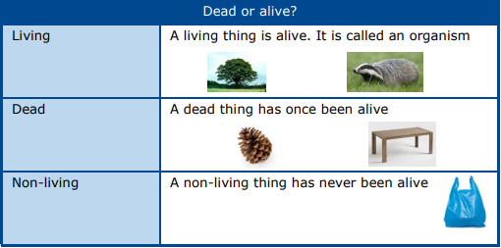

|  |  |
| --- | --- |
| Key vocabulary | |
| consumer | A consumer eats a producer or another consumer in a food chain |
| environment | The area that someone exists or lives |
| habitat | A place that an animal or plant lives. It provides food, water and shelter |
| inhabitant | A person or animal that lives in a place |
| microhabitat | A very small specific habitat for a plant or animal |
| organism | A living thing |
| producer | An organism that makes its own food, like a plant |

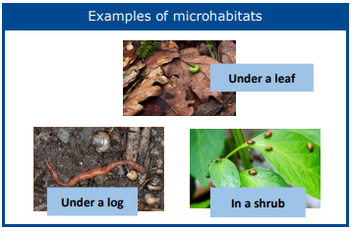

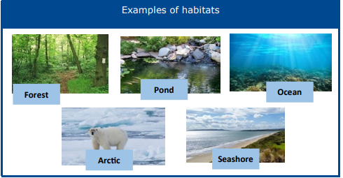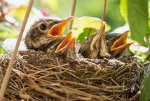

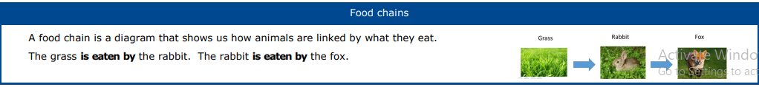

Year 2 Knowledge Organiser –plants

Focus: seeds and bulbs grow into plants, understand the needs of plants

|  |  |  |
| --- | --- | --- |
| Prior knowledge: | Key skills:  **Observation:**  looking at something closely  **Recording:**  accurately keeping your results- this could be measurements or observations which could be put into a table.  **Investigating:** Following a procedure to carry out an experiment  **Describing-using scientific language** | Basics:   Plants **are** alive even though they do not seem to move.  Seeds are a living thing.  All plants start out as seeds or bulbs.  Plants need sunlight to make their own food. |
| Key Vocabulary:   |  |  | | --- | --- | | bark | Outside layer of a tree | | berry | A small fruit | | blossom | The flower on a tree | | branch | Part of a tree that grows from the truck | | bud | Part of a plant that will grow into a leaf or flower | | flower | Part of a plant that contains the seeds | | fruit | Part of the plant that contains the seeds | | leaf | Part of the plant that makes the food | | petal | The coloured part of the flower | | root | Part of the plant that lives below the ground | | seed | Part that can grow into a new plant | | stem | The upright part of the plant that holds the flower up | | trunk | The upright part of a tree | | | Big Question    Facts:  Plants grow from seeds or bulbs. These germinate and grow into seedlings which grow into plants. Plants may have flowers, seeds, berries and fruits.  Seeds and bulbs need to be planted outside at particular times of the year and they will germinate and grow at different speeds.  Some plants are better suited to growing in the sun and some grow better in shade.  Plants need different amounts of water and space to grow well and stay healthy. |

Year 2 Knowledge Organiser – Materials

Focus: Uses of everyday materials

|  |  |  |
| --- | --- | --- |
| **Prior knowledge:**  Everyday material learnt in Year 1  Toys made of different materials | **Key skills:**  **Observation:** looking at something closely  **Recording:** accurately keeping your results- this could be measurements or observations which could be put into a table.  **Investigating:** Following a procedure to carry out an experiment  **Describing**-using scientific language | **Basics:**  To understand the language used to describe materials |
| **Key Vocabulary:**   |  |  | | --- | --- | | Names of materials | Wood, metal, plastic, glass, brick, rock, paper, cardboard | | properties | What a material is like and how it behaves (soft, stretchy, waterproof) | | Properties of materials | Opaque, transparent, translucent, reflective, non-reflective, flexible  Shape, push/pulling, twist/twisting, squash/squashing, bend/bending, stretch/stretching | | suitability | Having the properties that are right for a specific purpose | | Charles Macintosh | A Scottish inventor and chemist who invented waterproof fabrics in 1818. The Mackintosh raincoat was introduced in 1824 | | | **Big Question:**  Can we change materials? |