Knowledge Organiser – Animals including humans (Year 1)
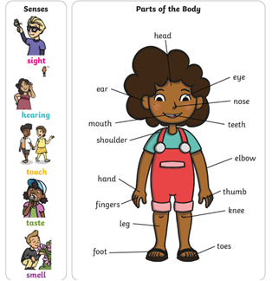 |  | 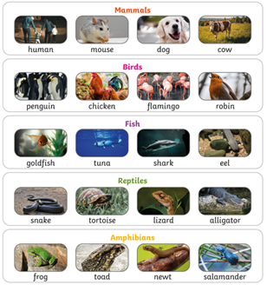
Key Vocabulary – Senses  Sight Your eyes let you see  Hearing Your ears let you hear  Touch Your skin gives you touch so you know if things are hot, cold, smooth or rough  Taste Your tongue gives you the sense of taste so you know if things are sweet, sour, spicy or salty  smell You smell with your nose | Big Question:  What is alive? |  | Key Knowledge – Animals  Amphibians Live in the sea as babies, live on land as adults  Birds Have 2 legs, a beak, feathers and wings  Fish Live and breathe water, have scaly skin, fins to help them swim and breathe through gills  Mammals Animals that breathe air, grow hair or fur and feed their babies milk  Reptiles Breathe air and have scales  Carnivore Animals that wat other animals (meat)  Herbivore Animals that eat plants  Omnivore Animals that eat plants and meat

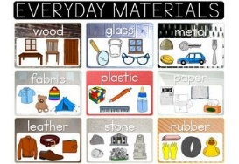 | Material properties  Soft – easy to cut, fold or change the shape of  Hard – cannot be broken or bent easily.  Shiny – reflects light easily.  Dull – does not reflect light.  Rough – feels rough or bumpy.  Stretchy – can be pulled to make it longer or wider.  Smooth – it is flat and has no lumps and bumps
Key Vocabulary  Material – Anything used for building or to make something else  Suitability – right for the purpose. It has the best properties for the purpose.  Properties – what a material is like and how it behaves. | Everyday Materials  Big Question  What are things made from? | Types of materials  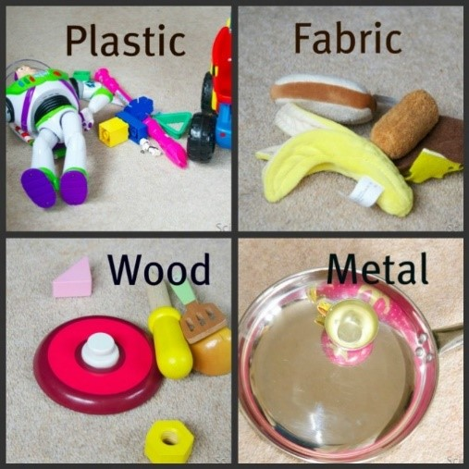
Houses are made from brick because they are solid.
Windows are made from glass because they are transparent, so you can see through them.
Saucepans are made from metal because metal gets hot so cooks the food.

Soft materials |  | Hard materials
cotton fabric polystyrene | paper rubber plastic glass | wood concrete metal diamond

Knowledge Organiser – Living things and their habitats: Plants
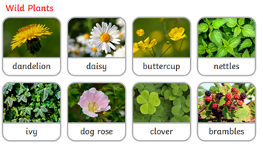 | 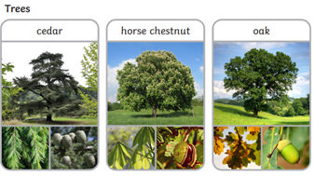 | 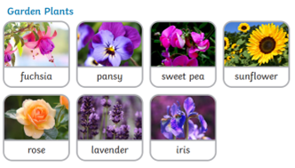
Key Vocabulary  wild plants - A wild plant seed grows where it falls. It doesn’t need to be planted or cared for as it grows.  garden plants - Garden plants are plants that people choose to grow in their gardens.  weed - Weeds are wild plants that grow in places where people don’t want them.  Deciduous - A deciduous tree loses its leaves each year.  evergreen - An evergreen tree keeps its green leaves all year round, even in the winter.  roots - Roots take in water and nutrients from the soil and keep the plant in the ground.  Stem - The stem holds the plant up and carries the water and nutrients from the roots to the leaves and flowers.  Leaves - Leaves catch sunlight to help the plant to make its own food.  flowers - Flowers attract insects and birds.  petals - Petals are the colourful part of the flower.  fruit - Fruit contains the plant’s seeds. Sometimes humans try to grow fruit without seeds because it’s easier to eat.  seed - Seeds grow into new plants. bulb Bulbs grow into new plants | 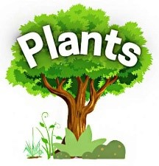  Big Question - Are plants alive? | 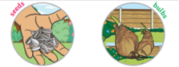
 | Parts of a tree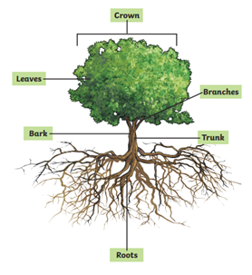 | 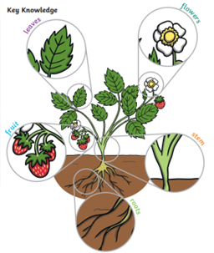

Knowledge Organiser – Seasons (Year 1)
Scientific skills  - observe changes across the four seasons  - observe and describe weather associated with the seasons  - observe and describe how day length changes in each season |  | 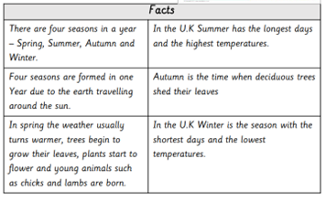
Key Vocabulary  Sun The sun is a star found at the centre of the solar system. It rises in the morning (sunrise) and sets in the evening (sunset).  Day length The time from when the sun rises until it sets.  Temperature A measure of warmth or coldness  Seasons Each of the 4 divisions of the year.  Weather Snowy, rainy, windy, sunny  Spring The months of March, April and May  Summer The months of June, July and August  Autumn The months of September, October and November  Winter The months of December, January and February  Sunrise The time when the sun comes above the horizon  Sunset The time when the sun goes down below the horizon | Big Question:  Why do leaves on trees colour and fall off?  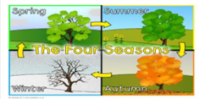 |  | Knowledge  - Know the four seasons in a year  - Observe changes in weather across the four seasons  - Understand/choose appropriate clothing to wear in each season (Record/Photograph what children are wearing (jumper, coat, hats, scarves, etc.)  - Make observations of how day length changes during the year.  Pattern Seeking: - At the end of the year:  - Look for patterns in evidence e.g. Does it rain more in Spring?  Do we have more sunny days in the summer?  Which was the coldest month?  Health and safety - Children should know:  - it is not safe to look directly at the sun, even when wearing dark glasses

