S t . A N T H O N Y ’ S C A T H O L I C

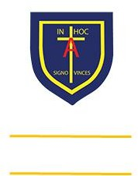

Learning, Growing And Living with Jesus

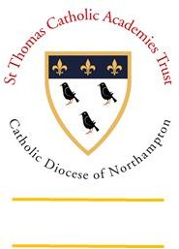

“The glory of God is

a human being fully alive”

P R I M A R Y S C H O O L & N U R S E R Y

In the Diocese of Northampton

Head Teacher: Mrs S Oppé, LLB, MA

Farnham Rd, Farnham Royal, Slough, Berkshire SL2 3AA Tel: 01753 645828 | Email: [post@stanthonys.slough.sch.uk](mailto:post@stanthonys.slough.sch.uk)

**Intention (Why do we teach what we teach?)**

We follow the Little Wandle Phonics scheme so that our learners:

* Are taught a coherent sequence of lessons that builds upon prior knowledge from pre-school/nursery
* Are introduced to phonemes, sounds & graphemes, and letters systematically
* Develop and apply blending and segmenting skills for both reading and writing
* Are provided with opportunities to apply their phonic knowledge when reading and spelling
* Are exposed to and taught phonetically decodable two-syllable and three-syllable words and the alternative ways of pronouncing and representing the long vowel phonemes
* Explore spelling patterns and grammar, alongside developing a breadth of knowledge, skills and understanding in the recognition and spelling of common exception words
* Develop confidence, resilience and engagement in phonics lessons and a love for reading and writing

# Implementation (How do we teach it?)

Our Phonics curriculum is taught:

* using the Little Wandle Scheme which sets clear expectations for pupils’ progress
* through a clearly defined structure to the teaching and delivery of phonics
* through direct teacher-led lessons that enable all learners to develop and apply new skills
* through lesson presentations, stories, games and additional texts that are carefully planned to allow children to apply and practise phonics skills
* through using the Little Wandle ‘How To’ videos which guides and supports teachers and support staff working with our children to feel confident in their own subject knowledge, and helps them to know that they are fulfilling the national phonics criteria
* through our ‘Reading Squad’ sessions and children then move onto Fluency books from the end of Year 2 onwards

# Impact (What has been the impact and how do we know?)

* The impact of the Phonics curriculum at St Anthony’s Primary School can be seen through:
* Our children’s enjoyment of reading and writing
* Our children’s skills and knowledge that demonstrates a systematic and progressive approach to the teaching of phonics
* Using our Assessment Tracker which indicates exactly which level the children should be reading at
* Our Reading Squad lessons which are targeted Guided Reading Sessions
* Our children’s fluency when reading, using segmenting and blending as key tools to success
* Our children try to read and spell common exception words accurately
* Our children’s try to use alternative spelling choices correctly and apply these in their writing
* Our children’s use of our ‘Fluency Books’ from Year 2 onwards