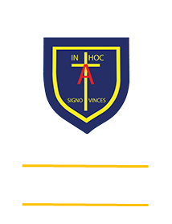
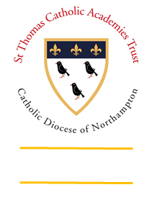
St. ANTHONY’S CATHOLIC
PRIMARY SCHOOL & NURSERY
In the Diocese of Northampton

Head Teacher: Mrs S Oppé, LLB, MA
Farnham Rd, Farnham Royal, Slough, Berkshire SL2 3AA
Tel: 01753 645828 | Email: post@stanthonys.slough.sch.uk

Learning, Growing
And Living with Jesus
“The glory of God is
a human being fully alive”

REQUEST FOR LEAVE OF ABSENCE DURING TERM TIME

I hereby request that leave of absence be granted to:

Child’s Name: ……………………………………………………. Class: ……………….…………...

Child’s Name: ……………………………………………………. Class: …………….……………...

FROM: …………………….….……… TO: (date returning to school): ………………………..….

Total number of school days requested: …………………………… days

Reason: ……………………………………………………………………………….…………………..

……………………………………………………………………………………………..………………..
(Leave of absence is only granted in exceptional circumstances)

Signed………………………………………………………… (Parent/Carer)

Date: ……………………………..……

A COPY OF THIS FORM WILL BE RETURNED TO YOU AFTER IT HAS BEEN SUBMITTED TO THE HEAD TEACHER FOR CONSIDERATION

For School Use Only

Number of “Leave of Absence” days taken in this school year: …………………………………………

Authorised / Unauthorised: ……………………………………….... Date: ……………….

Mrs S Oppé – Head Teacher

Visit us at: www.stanthonys.slough.sch.uk

