Nursery Long Term Plan
 | Advent 1 | Advent 2 |  | Lent 1 | Lent 2 | Pentecost 1 | Pentecost 2
Theme/ Topic  *Note: Any of these themes and topics can change across the year depending on the children’s interests | Family tree | Animals  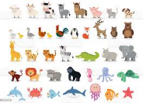 |  | Dreams | Footprints in the mud | Imagine that  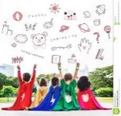 | Let’s celebrate
Phonics | Phonics Phase 1 | Phonics Phase 1 end |  | Phonics Phase 2  Ongoing  assessment on Phonics Tracker | Phonics Phase 2 end  Hearing and saying the initial sounds in words  Tricky words: I, no, go  Ongoing assessment on Phonics Tracker | Phase 3 starts (j, v, w, x, y, z, zz, qu, ch, sh, th, ng)  Segmenting the sounds and blending them together  Tricky words: the, to, into  Ongoing assessment on Phonics Tracker | Beginning to read CVC words  Tricky words: she, he, we  Ongoing assessment on Phonics Tracker –ready for Reception
Literacy/ additional stories | Bears from home to help settling in period  Tree  Leaf Trouble | The Letter  Jolly Christmas Postman One  Winter’s Day |  | Monkey Puzzle  Noisy Farm | The Bad Seed  The Cautious Caterpillar  Easter themed stories | Paula the Vet  Firefighter Pit | The Little Ouch  When I Grow Up  Lola Goes to School
Key text(s) to focus on | In My Heart  Peace at Last  Little Acorn  Wakey Wakey Big Brown Bear | The Gruffalo  Little Robin Red Vest  The Nativity Story |  | The Gingerbread Man  Elmer  Polar Bear Polar Bear What Do You Hear? | Old MacDonald  The Very Hungry Caterpillar  Willbee the Bumblebee | Little Red Riding Hood  Three Billy Goats Gruff  Shark in the Park | Firefighter Ted  Small’s Big Dream  Topsy and Tim Start School
Maths  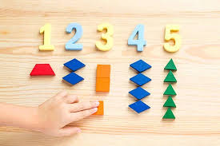 | Nursery rhymes  Patterns  Box models to be made throughout the year  Every day opportunities for counting orally  Visual 10’s frame who is in Nursery and not in Nursery | Numbers 0 – 5  2D shapes (circle, square, triangle, rectangle)  Repeating patterns  Positional language | Numbers 0 – 10  2D shapes (diamond, oval, semicircle)  Counting in everyday context  Capacity  Weight size |  | Numbers 0 – 15  2D shapes (pentagon, hexagon, heptagon)  Number rhymes  Numbers recognition 1-5 and beyond | Numbers 0 – 20  One more  Exploring numbers in the environment  Capacity  Weight  Size  Number recognition 5-10 and beyond | Numbers 0 – 20  One less  Shapes  Patterns  1:1 correspondence counting throughout the year
Science/UTW and RE topics | Getting dressed/ undressed  1.Myself | Colour mixing  1.Welcome (Baptism)  2.Birthdays |  | The five senses  Making gingerbread cookies  1.Celebrating  2.Gathering  Lenten Promises | Life cycle of a butterfly  Fruit testing  1.Growing  Stations of the Cross to visit | Seeds starts - planting  1.Good news  Mary to be crowned | Floaters and sinkers  1.Friends  2.Our World
Expressive arts and design  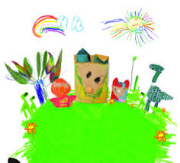 | Display work to be completed  Children’s work up from their visit on transition days  Family paintings  Paper plate faces  Drawing my family | Baptism candles  Creating with natural materials  Making animals  Autumn collage  Christmas Decoration Day crafts |  | Making instruments  Making Elmer from milk bottles  Junk modelling  Making and decorating gingerbread man | Making butterfly  Paper plate craft: making farm animals  Making a caterpillar from egg cartoons  Junk modelling: making stable and barn for animals | Junk modelling  Making a goat from paper plate  Making puppets with lolly pop stick | Salad bowl spinning- making planets  Paper plate craft: making vehicles  Making sun and ice cream from paper
PSED  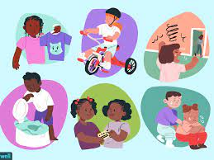 | I belong | We are all different |  | I am unique | My friends and I - relationships | What will I be? | I am changing
Trips/ people in school / enrichment activities  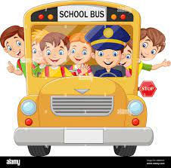 | Church visit  Autumn Trail  Favourite songs  Photos from home to make family tree – welcome/ hello in different languages | Christmas Decoration Day  Harvest theme  Invite parent in to talk about Diwali and how they celebrate it. Share photos in class.  Visit to the Church to act out a Baptism |  | Library visit | Stations of the Cross at the Church | Invite firefighter/ policeman/ nurse | Invite teacher or parent who speaks a different language to come and read a story to the children
Other festivals/ events | Birthdays – displays created | Christmas – Dec 25th  Diwali – oct 24th –Hinduism link |  | Valentine’s Day–  14th Feb  World Book Day -  2nd March | Mother’s Day – 19th March | Father’s Day – 18th June | World Environment Day
 | Bedtime stories after school with children and parents |  |  | Shrove Tuesday – 21st Feb | Easter – 9th April Easter Egg Hunt | Anti-bullying week  Superhero Day | Sports Day
 | Phonics workshop for parents | World Space Week |  | Ash Weds – 22nd Feb | Science Week | Class Assemblies | Transition Day
 |  | Hanukkah – RE link from 18th Dec-26th Dec |  | Pirate Day – Under the sea link | Eid – 21st April
 |  | Bonfire Night – 5th Nov |  | Internet Safety Day | Let’s go on a Safari – different animal a day to focus on
 |  | Remembrance Day – 11th Nov |  | Chinese New Year – 22nd Jan
Extra info | -Baseline children  -Get to know the children  -Transition and settling in  -Staggered start and home visits to take place | -Update data  -Christmas performance  -Independent writing assessment  -Moderate as a team – Literacy |  | -Phonics groups to be created  -Risk assessment for trip  -Independent writing assessment  -Moderation as a team - Maths | -Update data  -Phonics groups checked  -Risk assessment for trip  -Independent writing assessment  -Moderation as a team - Literacy | -Phonics groups checked  -Independent writing assessment  -Moderation as a team - Maths | -Final EYFS statements to be updated onto SIMs  -Phonics groups checked  -Independent writing assessment  -Moderation as a team – Literacy and look at GLD together
PP Children/ SEND children/ Vulnerable children suggestions of supportive activities | Settling into school  Supportive measures to be put into place for children who are struggling. E.g. eating in the hall/ TEACHH activities to be put into place if needed/ PHLO charts to be created and share with parents.  Support with uniform, wellies, PE kit concerns. | Staff to be trained on ‘Dingley’s Promise’ programme – EY inclusion programme. 10 courses over 5-year span, increase awareness of SEND children. |  | Pencil grips to be ordered and used, sound mats available to children, name card available to support them too. | Make playdough together in school to use in class – cooking skills, measuring, weighing, communication and language, PSED skills supported. | Story time in our school Library – supporting Literacy skills | Visit the local shops and buy healthy food to make a fruit salad together – independence skills

