MATHS  We are going to learn about transformations, which is something you began to learn about last year. If you can, complete the quiz and watch the video on this link:  https://www.thenational.academy/year-5/maths/an-introduction-to-translation-year-5-wk1-1  Draw a grid on a piece of paper, using a ruler and a pencil. Label the X and Y axes. Plot the coordinate (1,1) on the grid.  Now plot at least two more coordinates to create a shape. Now translate that shape 3 spaces right and one space up. Now try to find a way to reflect it on the grid. Try this with different shapes. Explain translation to someone at home.  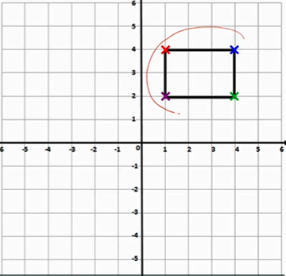 | ART  Last week you created some land art base on the work of Andy Goldsworthy. This week have a go at recreating the same picture using a different medium- collage, paint, chalk for example. Compare and contrast your art work. What are the similarities/differences? Which do you prefer and why?  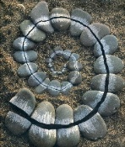 | RE  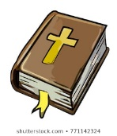  The bible reading this Sunday is John 10:1-10. If you have a bible read this short passage. Jesus describes himself as a shepherd. The flock come to him because they know they will get fed and be looked after. What qualities to you think a leader (or shepherd) needs. What are the responsibilities? Create a wanted poster for a new leader based on these qualites. Remember to state what the role is too. | LITERACY  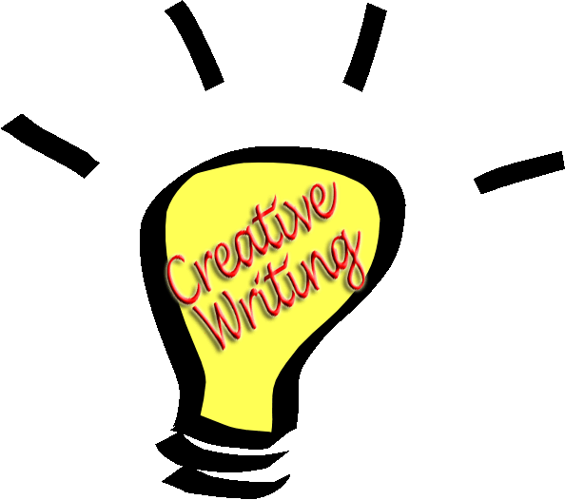  Tom Moore has captured the hearts of the nation. He has raised more than £30 million for the NHS walking around his garden and last week he celebrated his 100th birthday. See what you can find out about him and make a fact file telling people about his life. There is lots in the news etc about him!
WELL-BEING  In these strange times it is good to think about the people in our world that are doing things for others. People like doctors, nurses, postmen and women etc. Who is helping your family or household? Create a thank you poster for them to show how much you appreciate what they do. | SCIENCE  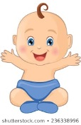  We have been looking into lifecycles. Last week you found a leaf , identified it and found out how it reproduces. This week, I would like you to think about the human life cycle. Think of the changes that happen as you progress from a baby to a child to an adult etc. Draw the life cycle describing the changes. | PE  Get creative and design your own assault course. This is a bit like some of the activities we do in sports day- going over things, round things, under things, jumping balancing etc. Who can be the most inventive? Encourage your grown-ups to join in too! | MUSIC  Last week you designed a back drop for the opera based on the Egyptian theme. This week put your talents to costume design. Think about the main characters, the Pharaoh and the hieroglyphics that come to love. How do you imagine they would look like?  