MATHS  Sort the numbers into at least 3 different categories. Numbers can be put into more than one category e.g. the number 10 is even and a multiple of 5.  Some vocabulary you may like to use is: Odd, Even, Factors, Multiples, Prime, Larger than, Square, Cube  16 4 27 100  64 13 90 7  86 45 21 62  320 77 81 105  Add your own numbers or ask somebody in your family to give you their favourite numbers to place in your sorting grid. | MATHS  Here is a times table grid. Have a go at learning a times table you are not too confident with for the week and try to learn it off by heart by then end of the week.  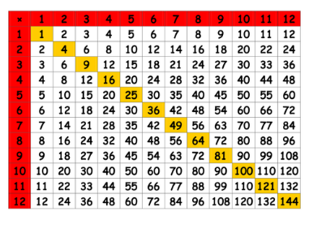  Get a family member to help and test you on when you are confident with it. | MATHS  Can you solve these worded maths problems?  Sam spent 92 minutes working on a school project. If he started at 5:30pm, what time did he finish?  Becky is reading a book with 567 pages. She has read 349 pages already. How many pages does Becky have left to read?  I think of a number, I double it and add 74. The answer is 290.  What number did I start with?  Challenge: Can you make up some of your own worded Problems? | ENGILSH  How many words can you make from the anagram wheel? All 9 letters can be used to make a word.  Can you try and make a nine-letter word from it?  R  C  S  O  H  Your text here  E  T  R  A
ENGLISH  Copy and complete the sentences below and highlight the relative pronoun for each sentence:  - John went to the match where he met his friends.  - We found the dog that belonged to Steven.  - The house was nowhere near the sea.  - This is the top Hybrid car which Mary wants to buy.  - It is one of the best movies I have ever seen.  Can you think of five more sentences of your own to write down including a relative pronoun? | ENGLISH  write an article for your school newsletter giving your opinion on what after school club is the best in our school. Think of all the afterschool clubs our school has to offer and choose one you want to promote the most.  You will need to:  - Point out the advantages of having this particular club.  - Mention the disadvantages of the club  - Convince the readers that your chosen club is the best out of all the clubs and give your reason why. | MUSIC  Think of your favourite song, can you write up a review on it. Think about who wrote the song, who is the artist, what instruments can you hear?  Make sure to mention why you like the song and how it makes you feel. Does it change your mood? How? | HISTORY  It’s time to travel back in time as we introduce our new topic: The Victorians. Can you make up a fact file of all the things you already know about the Victorians?  - Think about who the ‘Victorian’ period referred too  - What was the population like?  - Think back to when you read ‘Street Child’ and think about the key elements of what the different life styles were like.  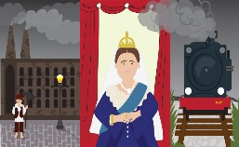
SPELLINGS  Choose the correct prefix to make a new word:  mis non co anti ex  clude operation  understood biotics  plain fortune  periment pectation  ordinate exsistent  freeze sense | SCIENCE  Get water to ‘Walk’ from one cup to another and create a colourful rainbow. You will need:  5 clear plastic cups  Red, Yellow and Blue food colouring  Paper towels  - Line up the cups & fill half of cup 1, 3 & 5 with water  - Add 4 drops of Blue dye into cup 1, 4 drops of Yellow dye into cup 3 & 4 drops of Red dye into cup 5  - Fold the paper towel, place one end into the cup with food colouring &  - the other end into the cup without.  Now watch the magic unfold! | WELLBEING  As we all know some days are not always a good day for us and as it was Mental Health Awareness a couple of weeks ago I thought it would be nice if you designed a Care package for your best friend or a family member to put a smile on their face and remind them why they are special to you.  Think about what the person may like and what interests you both share.  You could put:  A picture of you both  Their favourite sweets  Some colouring pencils or gel pens for you to write to each other.  A game  Their favourite song | RE  What events took place after Jesus was crucified. Put the following in order  After the ascension the spirit of God transformed many people’s lives.  After speaking to Mary, Jesus appeared to his friends  A few days later Jesus appeared before 500  Jesus told his friends to everyone he was the son of God  After 40 days Jesus said his spirit would come down and help his followers and then he would ascend into heaven

