MATHS  School Lunches: Your options for lunch are as follows:  Sandwiches: Cheese, Ham, Tuna, Chicken  Fruit: Apple, Banana, Orange, Grapes  If each student had to have a sandwich and a piece of fruit, how many combinations are there? Can you list them all? I’ve started one off for you: 1) Cheese Sandwich and an Apple  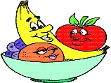  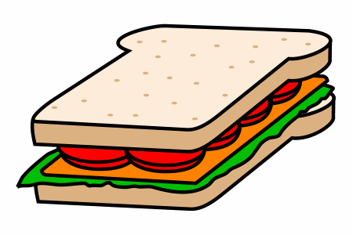  2).  Finished?  Can you create your own version of the problem? You can make it more tricky by adding different flavoured crisps or chocolate bars to the list. You could change the subject to something you relate to like Football tops and trouser colours, or Favourite subjects to study in the morning and afternoon.  Find out how many combinations there are. | SCIENCE  This week we will look at Reversible and Irreversible changes. In a reversible change the materials can change back to their original state. Irreversible materials cannot go back to their original state.  Make a list of household materials and write down whether they are Reversible or Irreversible once heated. Here are a few things you could look at:  Egg  Chocolate  Ice  Butter  Cake Batter  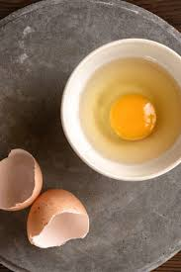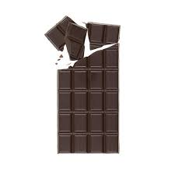 | RE  If you find yourself trying to stay motivated or inspired during this difficult time or needing some comfort and healing take some time out this week to read through these bible verses about Faith and pray to find the strength you need during this time of uncertainty.  Proverbs 3:5-6  If you put your complete trust in the Lord, you will be rewarded. He will set your life straight and lead you down the right path.  Philippians 4:13  God is always with us, providing guidance and strength, even in the most difficult of times.  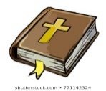 | WELL-BEING  Don’t let boredom kick in. Use this time to learn a new skill this week. This can be anything you want but here are some examples (Your parents may need to help with some of these)  - Learn the alphabet in sign language  - Help to make a new dish for all the family to enjoy  - Learn to say Hello in at least 10 different languages  - Plant a flower or a vegetable in a suitable environment to grow  - Practise a new skill on your favourite sport  Enjoy learning something New!
ENGLISH  It’s time for a Debate. Create an argument For and Against one of these topics:  - All Students should have daily chores  - School should be for only 4days a week  - Dogs should be kept on leads in parks  - Students should only do PE ‘IF’ they like it  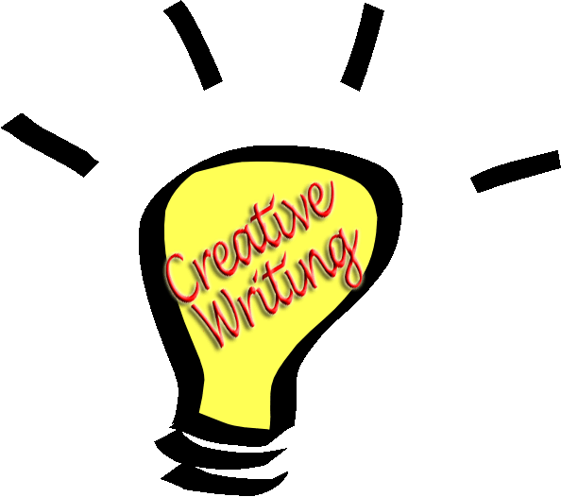  - Homework should be banned  Make sure you have at least 3-5 points For and Against your debate.  Use conjunctions to join paragraphs: As well as, This, Firstly, In addition.  ENGLISH  Using the concept from ‘The Boy at The Back of the Class’ can you create a written presentation on why it is important to lend a helping hand to people like Ahmet and his family. Using persuasive language to justify your points on how it might feel to be in a situation where the people and your surroundings are completely different from what you are used to.  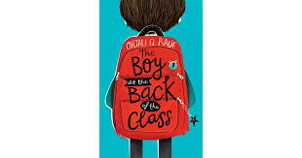 | ART & DESIGN TECHNOLOGY  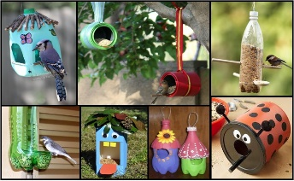  During this lockdown have you noticed how loud the birds sing during the day. Can you design and create a bird feeder for them using materials from home such as an empty juice carton, milk bottle or tin can. How would you decorate it to make it inviting for the birds?  SPELLINGS  Here is a list of spellings. Can you practise spelling these words and use each word in a sentence?  - Familiar  - Exaggerate  - Ancient  - Nuisance  - Curiosity  - Guarantee  - Recognise | PE  Write down a selection of various exercises and outdoor activities on a piece of paper, rip them up and fold in to small quarters. Put them into a hat or a bowl and get every member in your family to pick an exercise for you to do for the day. They can join you too if they are brave enough.  Remember to write down how many times to do a certain exercise  10 Star Jumps, 2min Wall Sit, Football Kick Ups, 15 Sit Ups etc  ENGLISH  You have just opened your front door and the image below is in front of you. Can you use your Senses to describe the setting? What can you Hear, Feel, See, Smell  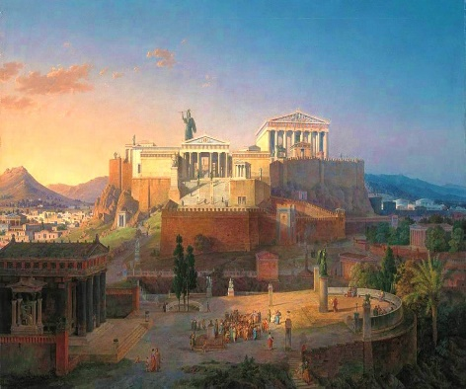 | MUSIC  Can you design an Egyptian themed leaflet or poster for the Opera? Some of It can be made up but It must include:  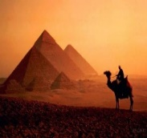  - The time  - Date  - Venue  - Ticket price  - Picture  - A blurb about the opera (Remember don’t give too much away)

