MATHS  This week we are going to look at lines of Symmetry. Copy the shapes below onto a piece of paper and draw all the lines of symmetry for each shape. As a challenge write out your name in capital letters and work out all the lines of symmetry for each letter. Are there any letters that have more than two lines of Symmetry?  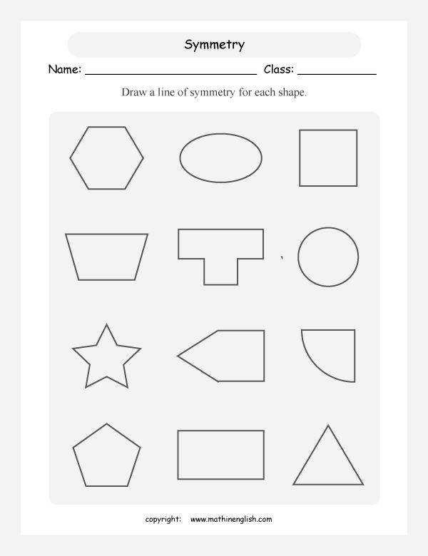 | ART  It’s time to take your artistic talents outside and make some Natural Sculptures in the style of Andy Goldsworthy. You can use Leaves, Sticks, mud, flowers and stones. He often makes circles, spirals, swirls and arches. Be as colourful & creative as you like and send your pictures to us.  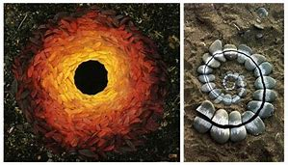  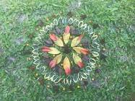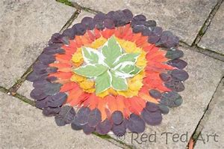 | RE  This week’s gospel reflects on Trust. Think of all the people you trust and create a mind map of all the qualities that make them trust worthy. Is it that they are Loyal, honest and open, dependable and or reliable that makes them trustworthy?  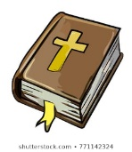  ‘Trust me in your times of trouble, and I will rescue you, and you will give me glory.’ Psalms 50:15 | LITERACY  Choose one of your favourite places. This could be a famous landmark like Wembley Stadium, a place that you visit often or even your home.  Create a tourist information leaflet about why people should visit your chosen place.  Ensure that you:  - Include any activities that they can do there  - Use adjectives and explain why this place is so great  - Promote any facilities such as shops and restaurants  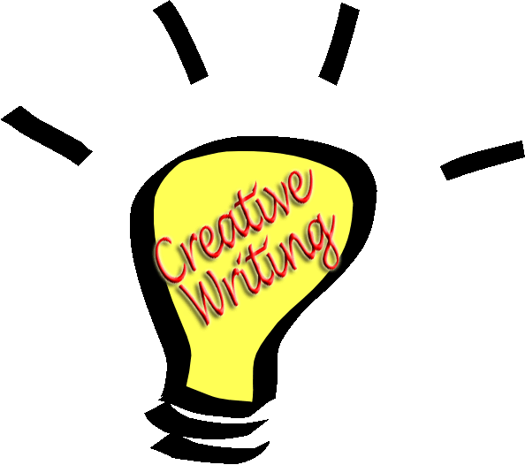  - Give directions or possibly draw a map  - Discuss who this place is most suitable for
GEOGRAPHY  Choose another country in the world which you can compare to your own country. Can you create a comparison which shows how they are different or similar? Research:  The Weather  The Population  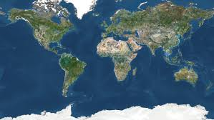  The Language  Famous Landmarks  The Religions  Present this in the form of a poster, leaflet, a table and don’t forget to add pictures of their Flags. | SCIENCE  This week we will look at identifying properties of materials and know some of their terms and definitions.  Find 3-5 different objects around the house and write down all their properties. Are they Opaque, Shiny, Insulators, Rigid, Waterproof, Hard, Transparent, Soft, Smooth? Use a dictionary, or glossary to find the meaning of any words you’re unsure of.  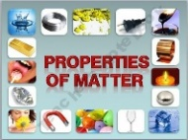 | PE  The 7 Day, 7minute Fitness HITT  Your challenge is to try and do this 7minute HITT EVERYDAY this week holding each exercise for a minute and ensuring you start with a minute Warm Up/ Stretch and finishing with a minute Cool Down.  - Warm Up/ Stretch=1min  - Press ups=1min  - Sit ups=1min  - Triceps Dip with a Chair  - Plank=1min  - Squats=1min  - Cool Down/ Stretch=1min | MUSIC  Put your Listening skills to the test by listening to a piece of music and make a list of all the instruments you can hear. How did the music make you feel? Can you think of some adjectives to best describe the music?  