HISTORY  We are looking at natural disasters this term. Volcanoes and tSunamis are both natural disasters, what can you find out about these?  Create a fact file on both of these.  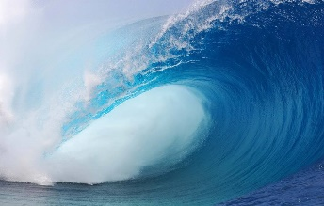 | ART  To link in with your outdoor activity you are asked to draw a picture of your walk including your notes on the 5 senses.  How best can you include these in your picture?  Be sure to make your picture as colourful as possible.  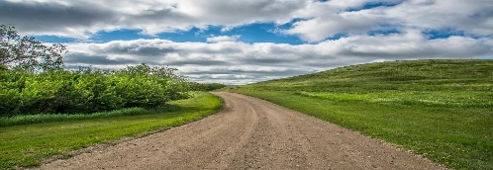  This Photo by Unknown Author is licensed under CC BY | RE  Think about all the heroes that are working in hospital’s around the country.  Write a prayer for them showing your appreciation and respect for them during this time.  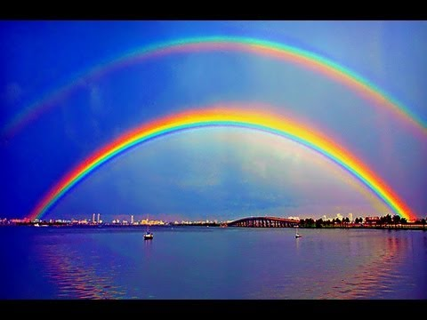 | LITERACY  You will need to find your favourite book or a book that you have read recently and really loved.  You are going to write a review on this book. Here are some things you can include in the review.  -Who are the characters?  -Where is the story set?  -What did you enjoy about the book?  -If you could change one thing about the book what would it be?  Make sure that you don’t give the ending away 😊
MATHS  Last week you created codes with emojis. This week you are going to create codes using your times tables answers. Use these numbers to create a special code for the teachers to crack! Each number will stand for a letter in the alphabet.  Eg. 6 x 7 = 42 = A  9 x 3 = 27 = B  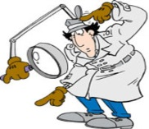 | SCIENCE  Time for some design.  This week you will create your own digestive system by using items from around the house to represent the different parts of the digestive system. For example, you could use the cardboard from inside the kitchen roll to create the oesophagus. We are looking forward to your creations.  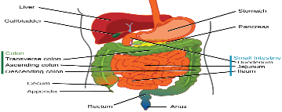  This Photo by Unknown Author is licensed under CC BY | _{GEOGRAPHY}  Design and create your own double page spread  Look at some of the natural disasters we have covered already (blizzards, earthquakes, and volcanoes) use the information you have already or even better do some more research of your own to create an eye-catching and colourful double page spread!  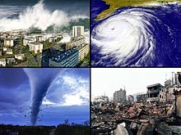  This Photo by Unknown Author is licensed under CC BY-SA | Outdoor Activity  This week you will need some paper and a pencil. When you are out taking a walk this week, we want you to take notice of what is around you!  Using your five senses take note of what you can see, hear, smell, touch, and taste around you.  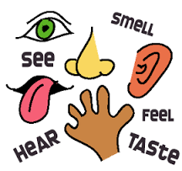  This Photo by Unknown Author is licensed under CC BY-NC-ND
Year 4 Week Commencing 27.04.20

