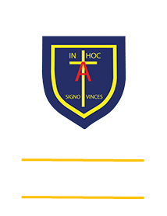
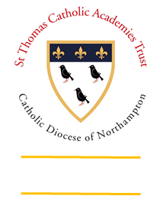
St. ANTHONY’S CATHOLIC
PRIMARY SCHOOL & NURSERY
In the Diocese of Northampton

Head Teacher: Mrs S Oppé, LLB, MA
Farnham Rd, Farnham Royal, Slough, Berkshire SL2 3AA
Tel: 01753 645828 | Email: post@stanthonys.slough.sch.uk

Learning, Growing
And Living with Jesus
“The glory of God is
a human being fully alive”

Year 3 home learning – week commencing 11th May 2020
Art  Design and make a birthday car using recyclable materials in your home. | History  Investigate who the Normans were and when they came to England. | Maths  What you need to play:  A series of cards/pieces of paper  How to play:  Step 1: Both players put a card on their head. It could have a number on it, a shape etc….  Step 2: The first player asks a question which can only be answered with ‘yes’ or ‘no’. E.g. ‘Am I odd?’ ‘Am I under 20?’ ‘Do I have 4 sides?’ etc…..  Step 3: They keep asking questions until the get the answer correct, or they run out of turns (you can set the number of turns they get at the beginning of the game). Then it is time for the other player to have a go. | English  Diary writing  Create your own daily diary where you write down your own thoughts and ideas during these challenging times. Your diary entries can be as simple or extravagant as you like but it is something that you will be able to look back on when you are older
Science  Chocolate welding  Design a building using melted chocolate and marshmallows | Geography  Create a two-page spread looking at the similarities and differences between India and the United Kingdom | RE  Moses was given the ten commandments by god to share with his followers. Read through the ten commandments and then try to rewrite them in your own words. | Music  Pick your favourite song on the radio now and create your own dance routine for it.
Remember to constantly challenge yourself. Can you do better?

