Year_6_Week_Commencing_Monday_18thMay
Reading:  Continue to read the next chapter of ‘The Legend of Podkin One-Ear' each day with an adult.  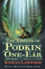  Read something else for fun! Although we may not be at school, you are in Year 6 and should have a vast range of reading skills. Try reading something that you wouldn’t normally read. | Literacy:  Design a front cover for your own book. Look at the cover of Podkin for inspiration.  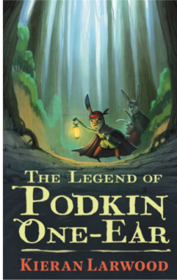 | Literacy:  Using all the tasks you have done over the last few weeks create your own short story.  Think about your main character, the magical possession they may have or must find. The kingdom they live in. Then of course your baddie. | Literacy: What Have You Learnt!  Think of what you have learnt in the last few months of being in Year 6 (or in years of being at St Anthony’s).  - What have you learnt that has surprised you?  - What have you learnt that you thought you wouldn’t?  - What are the most important skills you have learnt?  - What would you pass on to someone else?  Challenge: Can you write those ideas in the form of a poem?
Literacy:  Creature of the deep! 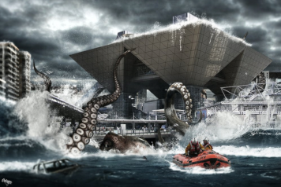  Where do you think the creature has come from? What type of kingdom? Is it a man-eating monster? Why do you think it has come up to the surface? Is it possible that there are sea creatures as big as this one lurking in our waters? | Maths:  Continue to master your skill of telling the time. Can you write them down in the 24-hour format?  Get an adult at home to test your new skills! | Maths:  Use the following numbers, only ONCE, to make calculations where the answer is as close to 117 as you can get.  Use brackets correctly  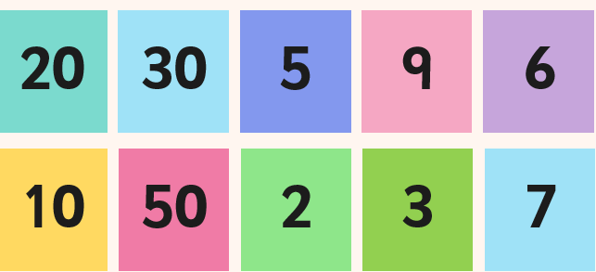 | Maths: Word Challenge!  Miss O’Brien is painting her house. To make a litre of light blue paint she needs 2 tins of blue paint and 3 tins of white paint.  If Miss O’Brien requires 9 litres of light blue paint to her house, then how many tins of blue paint and how many tins of white paint does she need?
RE:  Think how you can be a witness to the holy spirit. Make your own 7-day plan for over the next week where you must do a kind gesture.  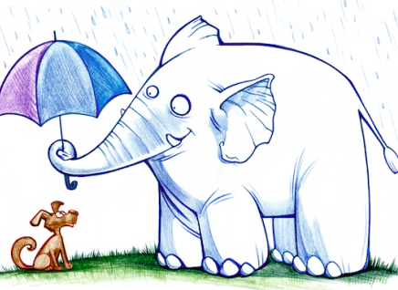 | TWITTER:  Keep up-to-date on the St Anthony’s Twitter page!  Lots of your pictures are on there, plus you get to see what the other year groups are up to. | History:  Research Sir Francis Drake and form a file of all the facts about his life.  - Who was he?  - What did he do?  - Why was he so important? | Science:  Design a handwashing station for a school in Kenya using collected rainwater  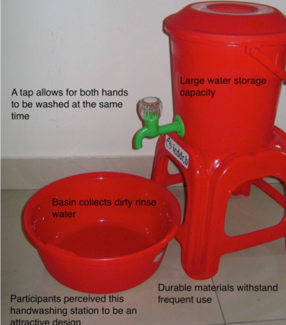
Spellings: Find 10 words that can be nouns as well as verbs. Learn to spell these words. | PE:  This week I want us to take a moment. Breathe deeply and be thankful to God for all that we do have in this difficult time.  Yoga is perfect to help us to calm.  Find some space where you won't knock anything over.  https://www.youtube.com/watch?v=oyfQp0dDlug | Art & Design Technology:  Draw your own cityscape. Think about what your city scene might be: London, New York, Paris, Milan etc.  Then the lights, the colours. Is it night or day?  FRIDAY FOOD CHALLENGE:  Find an ice cream recipe. What is your favourite flavour? | Wellbeing:  Write a letter to a family member or a friend. You might want to say how much you are missing them. What you plan to do when lockdown is over. Where will you both go?  Have fun decorating the letter to. If you have time and are allowed go and deliver it.
WORRIES:
Being at home with lots of time on your hands can make us all worry more. Now might be the perfect time to keep a diary! You all remember the diary we read from Anne Frank, now we might not be a war, but it is still a great idea to help ease your worries and would be something great to look back on in years to come. Almost like your own time capsule.

