Week Commencing Monday 11th May
Reading:  Continue to read the next chapter of ‘The Legend of Podkin One-Ear' each day with an adult.  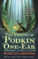 | Literacy:  Podkin, Paz and Pook are trapped. Writing from Podkin’s perspective, write a letter to Brigid asking for help. He knows she has magical powers and is desperate for her to help them: save them. | Literacy:  Create your own foxpaw game. Write instructions (detailed instructions) about a made-up game that requires a dice.  Does the game need 1 or 3 dice? Are there special markings on them? How do you win?  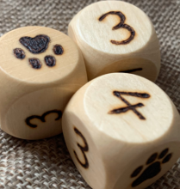 | Literacy:  Out of Control! Write a short story about this picture.  What vehicle is the driver operating?  What might he have seen in front of him?  What is the weather like outside?  Is there anyone else depending on the driver to salvage the situation?
Literacy:  Some of your teachers are becoming YouTube sensations. Go take a look at them and write a book review on the book they are reading. Remember what is important in a book review:  - Title and author  - Overview of the story: talk about the characters, the setting etc.  - What did you like?  - What didn’t you like?  - Would you recommend it? To whom? | Maths:  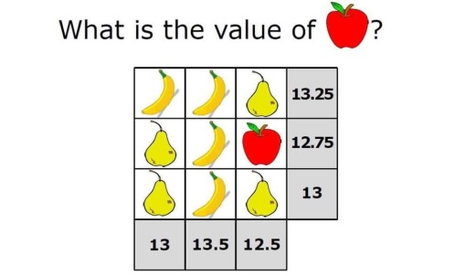 | Maths:  Telling the time is a very important life skill. If time is something you know you struggle with then it is time to get learning.  Find a clock in your house and an adult. Ask them to help you. Begin with terms like o’clock and half past, then quarter past and quarter to.  Good luck! | Maths: Word Challenge!  Time to learn some Tudor Money:  1 shilling = 12 pennies, 1 crown = 5 shillings,  240 pennies = 1 pound, 1 pound = 20 shillings  Mrs Blackiston went to the market with 4 POUNDS and brought a fresh loaf of bread with 3 SHILLINGS. She then went to the fishmonger and brought 3 pieces of fish for 8 PENNIES. Finally, before she went home, she brought some ale for 2 CROWNS.  How much money did Mrs Blackiston spend?  How much money did she have left?
RE:  People are witnesses to their faith by working in the community. Write a profile of a local charity.  1). Who founded it and why?  2). What was their inspiration, how do they help people and why do volunteers give their time to help others?  3). Explain what a difference it makes.  Suggested charities:  SHOC (Slough Homeless Our Concern), Slough Outreach, Slough Refugee Support, Thames Valley Hospice | TWITTER:  Keep up-to-date on St Anthony’s Twitter page!  Lots of your pictures are on there, plus you get to see what the other year groups are up to.  NO SATS!!  Take some time to celebrate that you no longer have to take your SATS! 🙌🙌🙌🙌🙌🙌🙌🙌🙌🙌 | History:  Design a masquerade ball mask like from Romeo and Juliet. This could be from anything around the house. Paper plates, an old pair of sunglasses or you could get some paper and pens and get creative. | Science:  Building a rollercoaster. You can use anything! Look around the house for pipes, straws, toilet rolls etc. Your recycling would be a great start.  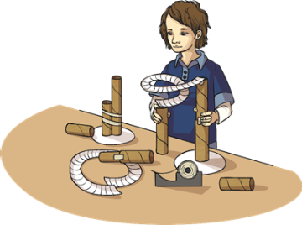
Spellings: Find 10 words that start with the prefix –Over. Learn to spell these words. | PE: Last week was May 4th … may the fourth be with you  Throughout this week take on the Jedi challenge.  On odd numbered days:  - 20 Jumping jacks  - 10 Heel flicks  - Hold a plank for 20 seconds  - 10 Squat jumps  On even numbered days:  - 10 Burpees  - 20 Mountain Climbers  - 10 Squats  - 20 Bunny Hops | Art & Design Technology:  This week’s cook is BURGERS! Yum!  Ingredients:  - 500g minced beef  - 3 spring onions  - 2 cloves of garlic  - 1 tsp of paprika  - 1 tsp dried parsley  - Pinch of black pepper | Wellbeing:  Go outside. Whether that be in your back garden or on your daily walk.  Look up!  Look at the sky, watch the clouds. Can you spot the patterns of the clouds? Draw a picture of the different shapes and their sizes.
WORRIES:
We all have worries (yes, even your teachers) and that is OK!

Write them down! Share them! It is good to talk and open up.

A problem shared is a problem halved 😊

