Reading:  Read a chapter of ‘School Swap’ from Purple Mash each day with an adult. | Literacy:  Create a character map based on one characters from ‘School Swap.’  - What is the problem that this character is facing?  - How do they help to solve the problem?  - What are some of their character traits?  - What do you know about the character?  - Did the character change over time? How?  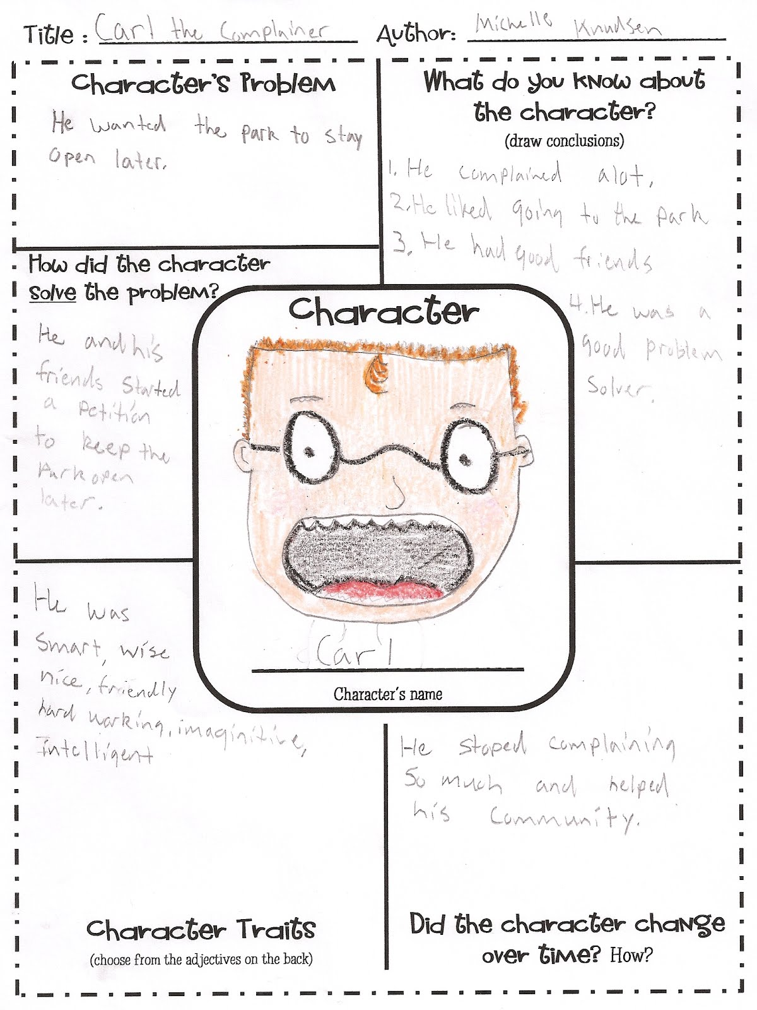 | Literacy:  Complete these sentences using the correct homophone. ( their, they’re, there)  “Look at the beautiful rainbow over !”  gasped Lydia.  The one with the white fences is house.  Do you think hiding?  Put the book over ___________ on the shelf.  ___________ bus was running late.  The cold wind made __________ teeth chatter. | Literacy:  Choose the correct spellings to complete the sentences below.  1. Since being in Year 5, Jay kept getting himself in sereous/serious/serous trouble. Mr Jones did not find his antics very humoreous/humorious/humorous and thought that Jay’s behaviour was outrageous/outragious/outragous.  2. Explain why a comma has been used in the sentence below. Ten minutes into detention, Mr Jones cleared his throat and beckoned with a finger.
Maths:  I have 1 litre of water in a jug. On the way to my table I spill some. I have 500ml left. How much have I lost?  Charlie and Jake are watering the plants, Jake fills his watering can up with 4 and a half litres of water and Charlie fills his up with 7 and a half litres of water.  a) How much water have they used?  b) How much have they used if they water the plants twice? | Maths:  Kate has a piece of ribbon one metre long. She cuts off 30 centimetres. How many centimetres of ribbon are left?  Holly takes half an hour to walk from home to school. She arrives at school at 8:25am. At what time did she leave home?  A cake weighs 560 grams. If I cut the cake into 8 equal slices, how much would I expect each slice to weigh approximately?  Kirsty ran a race in one and a half minutes. Mina took 10 seconds longer. How many seconds did Mina take to run the race? | Maths:  A class wants to investigate how much chocolate is eaten in 1 day (by people in their class). 12 people eat 25g of chocolate, 7 people eat 35g of chocolate and 9 people eat 50g of chocolate. How many grams of chocolate have been eaten in one day?  Megan wants to fill a bucket with water. A bucket holds 6 litres. A jug holds 500 millilitres. How many jugs of water does Megan need to fill an empty bucket?  A bottle holds 1 litre of lemonade. Rachel fills 5 glasses with lemonade. She puts 150 millilitres in each glass. How much lemonade is left. |  | Maths:  Jamie, Kate and Hassan run a 50m race. Kate’s time is 13 seconds. Jamie finishes 5 seconds before Kate. Hassan finishes 3 seconds after Jamie. What is Hassan’s time in seconds?  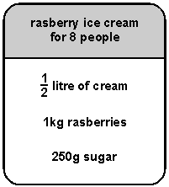  Here is a recipe for raspberry ice cream. This recipe is for 8 people. Josie makes enough raspberry ice cream for 12 people. How much cream does she use?
Religious Education:  Pentecost is when the Holy Spirit was first given. How do you think it changed the disciples and how does it help us today? | Physical Education:  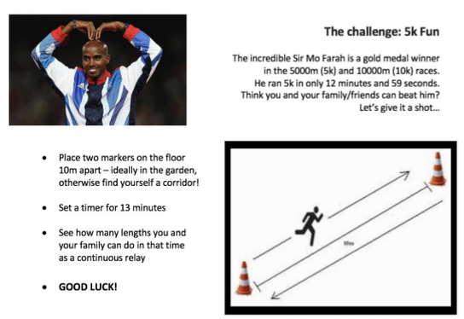 | Science:  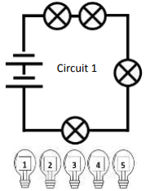  Underneath each circuit, predict the brightness of the bulb(s) compared to the other circuits by indicating on the scale. 1 = dimmest to 5 = brightest.  Explain why.  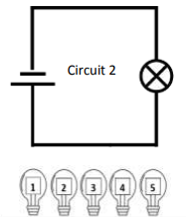 |  | Outdoor Activity:  There is so much more to what’s through our window that what we can see. This activity encourages us to listen to everything going on out there, and to think about different ways of recreating and recording the symphony of sounds.  Can you recreate the sound(s)? You could use your voice, your body or anything you can find in the house. If you are with others, try and recreate the combination of sounds you heard outside
Art:
When the Holy Spirit came, it was described as tongues of fire settling on the disciples.
Draw a picture of how you imagine this to be.

