Reading:  Read a chapter of ‘Beth on the Nile’ from Purple Mash each day with an adult.  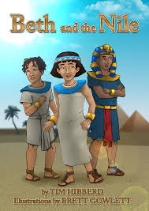  If you have completed this book, you may start a new reading book and read one chapter each day with an adult. | Literacy:  Ancient Egyptians were not frightened of death because they believed that the Afterlife would be brilliant. What would your idea of a perfect Afterlife be?  Imagine that you arrived in the perfect Afterlife. Use your five senses to help describe what it would be like. Use lots of adjectives to help the reader get a picture in their mind of what it would be like, too! | Literacy:  In the story ‘Beth on the Nile’ hieroglyphs have been used to create a message. Create your own hieroglyphs or secret code.  Write a message to someone in your family using your code. Can they manage to crack your code?  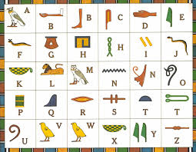 | Literacy:  1. Rewrite the sentence below so that it is punctuated correctly.  What a strange request exclaimed Leyton-Nefer  2. Change the following sentence so that it is written in the present perfect tense.  The strange man spoke to Beth’s dad.
Spelling:  Write a list of at least 10 words that end in –ght.  Then write a sentence for each making sure to use the word in the correct context.  Test yourself! Cover up the words and see if you can spell them correctly. | Maths:  Write the times for breakfast, lunch and dinner of a Saturday in digital and analogue format. Make sure you use am and pm correctly.  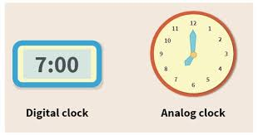 | Maths:  How long to the next hour from:  - 4:54  - quarter to 12  - twenty past nine | Maths:  Complete each sentence.  4:35 + ☐ minutes = 5:05  11:30 – ☐ minutes = 10:40  6:14 + ☐ minutes = 7:00  8:45 + 18 minutes = ☐
Religious Education:  Based on what you have previously learned about Hindu gods and mandala art create a poster on Hinduism.  Do some research to find out the 5Ws on Hindu worship (who, what, where, when, why). Add this information to your poster. Don’t forget to make your poster look colourful and interesting!  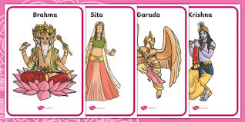 | Physical Education:  Playing Card Fitness!  You will need a deck of cards. If you don’t have one you can create your own with 13 squares of paper. Mix up the cards and do whichever activity the image below shows! Have fun!  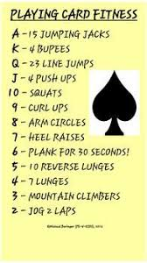 | Science:  Based on all the learning that you have done on earthquakes, create a quiz with at least twelve questions. They could be a combination of multiple choice, written response, label, and fill-in-the-blank. Once you have created the quiz test an adult to see how they do!  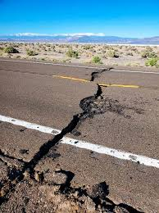 | Outdoor Activity:  While outdoors, take in your surroundings. Don’t forget to breathe deeply. Think about what you can see, feel, smell, hear or maybe even taste!  Think about some things that you are thankful for today!  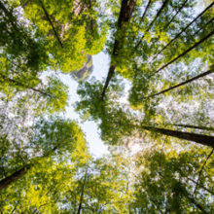
Art:
We are all capable of feeling many different emotions. Think of one of the strongest emotions you have felt today or in the past week.

Draw what you think this emotion would look like. What colours would suit this emotion best?

Perhaps you felt many different emotions all at the same time! Feel free to draw as many as you like!

