Reading:  Read a chapter of ‘Beth in The Nile’ from Purple Mash each day with an adult.  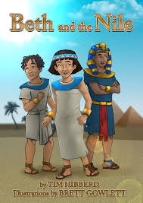 | Literacy:  Create a character map based on one characters from ‘Beth in The Nile.’  - What is the problem that this character is facing?  - How do they help to solve the problem?  - What are some of their character traits?  - What do you know about the character?  - Did the character change over time? How?  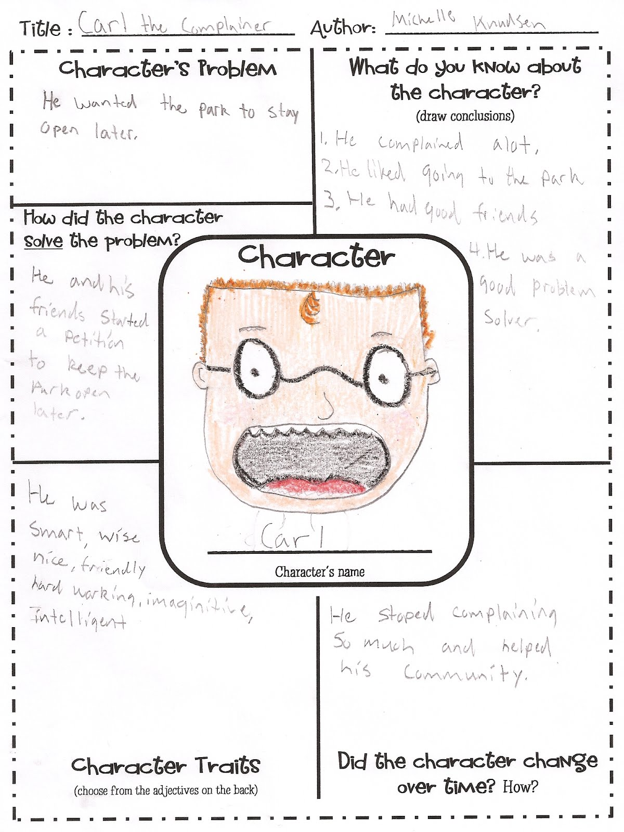 | Literacy:  Write out and complete each sentence below with the most suitable word from the boxes. Use each word once.  because  until  although  a) Normally a sarcophagus wouldn’t be requested _________ someone had died.  b) _________ she was only a child, Beth had a job.  c) People were not afraid of dying ________ they were excited about going to the Afterlife. | Literacy:  Underline the correct spellings to complete the sentence below.  The story is set in Egept/Egipt/Egypt, a country famous for its pyramids/piramyds/pirymids and hierogliphs/hieroglyphs/hyrogliphs where a misteryous/mistyrious/mysterious man made a strange request.  Write the sentence out neatly with the correct spellings.
Literacy:  Some of your teachers are becoming YouTube sensations. Go take a look at them and write a book review on the book they are reading. Remember what is important in a book review:  - Title and author  - Overview of the story: talk about the characters, the setting etc.  - What did you like?  - What didn’t you like?  - Would you recommend it? To whom? | Maths:  Every year, 15 schools take part in in a charity fundraiser. Children from the schools donate pennies, which are then collected up and sent to the charity. Mo works for the charity and receives the donations from the schools.  Challenge 1:  In 2018, the charity received a total of £1440. Mo noticed that their records show that 15 payments were made (1 from each school), payments were received on 8 different dates, and the same total amount was received on each of those 8 dates.  Find two different ways that this could have happened. | Maths:  Challenge 2:  In 2019 the charity again received exactly £1440, Mo noticed that if the 15 payments were arranged in order from smallest to largest, the amounts went up in equal steps.  Find three different ways that this could have happened. | Maths:  Challenge 3:  Mo wondered if in 2020 the patterns they had noticed in 2018 and 2019 could both occur at the same time. In other words, that the total received on each of the 8 dates are equal, the 15 different payments go up in equal steps and the total amount received is £1440 again.  In how many ways can this be done? How do you know?
Religious Education:  Find out about one of the Hindu gods or goddesses and create a double page spread about them.  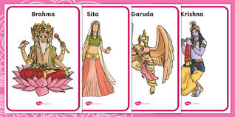 | Physical Education:  Create your own exercise sequence.  You might even be able to make your own obstacle course outside!  For example, you might choose to do a combination of these movements, in between hopping over or dodging various obstacles.  Jumping jacks  Squat jumps  Burpees  Mountain Climbers  Squats  Bunny Hops | Science:  What is an earthquake?  What are the different levels of an earthquake?  How are they measured?  Research an earthquake that has taken place and create a newspaper article describing the event. Remember to answer the 5 Ws.  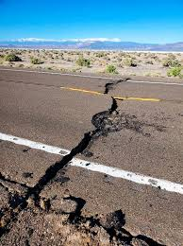 | Outdoor Activity:  While you’re in your garden or on a daily walk, look at the sky and watch the clouds. Can you spot the patterns of the clouds? Draw a picture of the different shapes and their sizes.
Art:
In RE, you are learning about Hinduism this week. Draw and colour your own mandala!

