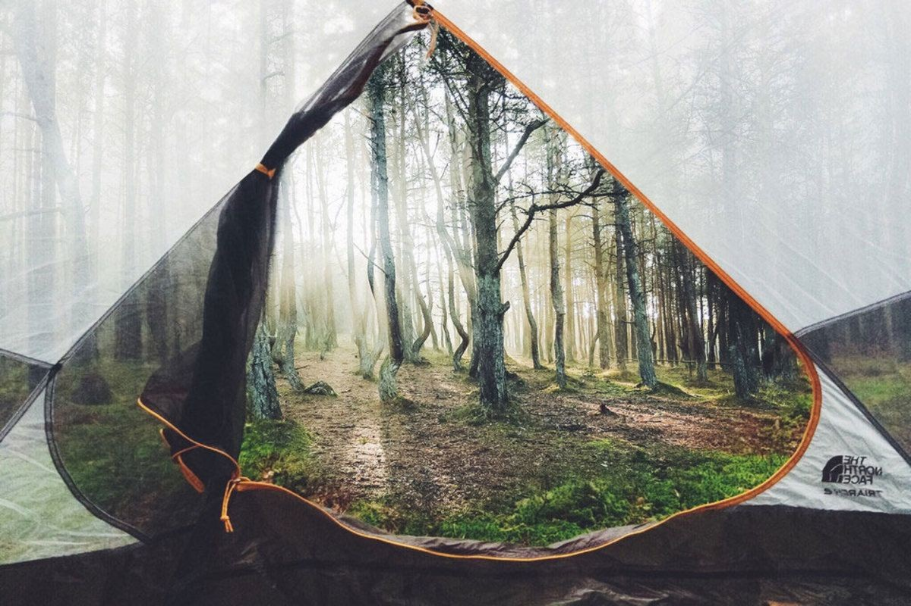

Reading: Log on to bug club each day and complete 20 minutes reading.  Own load a book to read for enjoyment.  Why not try Letters from the Lighthouse by Emma Carroll.  Remember the more you read, the better vocabulary you have and the better your writing can become. | Literacy:  Monday is World Ocean day. Log on to take part in exciting learning opportunities linked to this topic.  Create a fact file about plastic pollution in our oceans. Include the facts, problems and suggest some solutions | Literacy:  . Monday is World Ocean day. Log on to take part in exciting learning opportunities linked to this topic.  Write a letter to our local MP about the need to clean up our water of the plastic that is destroying our water. Use facts from the World Ocean Day schools website to help you get the facts correct. Be formal and factual. | Literacy: Use this image to write the story.  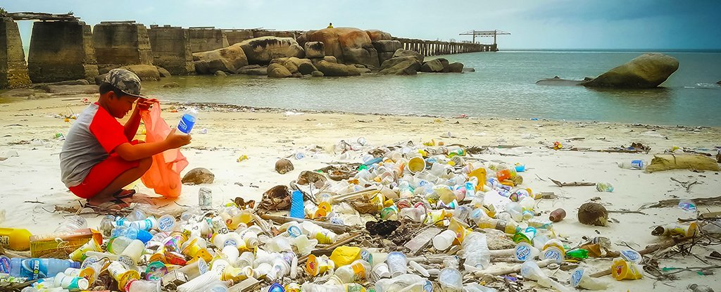
Literacy:  Find 10 words that have the prefix ‘ex’  Make sure that some of the words are new to you to build your vocabulary | Maths:  Practice multiplying fractions.  ½ x ¼ = 1/8  Write out some problems and teach someone else in your household how to do this. | Maths: Write out yourself, 5 long addition and subtraction calculations and solve them using our written methods.  If you get them wrong, go back through your method and see if you can correct yourself. This isn’t timed so take care and focus. | Maths: WORD CHALLENGE!!  I’m thinking of a number…  I add 10  I half it  X it by 3 and my answer is 6  What was my number?  I’m thinking of a number…  I subtract 5  I double it  I divide it by 3 and my answer is 10  What was my number?
RE: St Anthony of Padua  On Saturday is the feast day of St Anthony of Padua.  Find out all about our patron saint.  Create a quiz about him. Keep the answers safe. Try out the quiz on a friend via social media.  Join the school service on Friday morning via zoom | Friday Food Challenge: Banana Pancakes You will need:  350g Self-raising flour 1 tsp Baking powder 2 very ripe Bananas 2 eggs  1 tsp vanilla extract 250ml milk Butter, for frying  1. Sieve the flour, baking powder and a pinch of salt into a large bowl. In a separate bowl, mash the bananas with a fork until smooth, then whisk in the eggs, vanilla extract and milk. | History: Watch Horrible Histories each day at 9:55  What have you learnt about the past?  Jot down some facts and then tell someone about your learning in a phone call  There is also a Henry VIII special on Monday @7pm | Science: Watch Operation Ouch on CBBC each day at 10:50 or in the afternoon.  Record same facts you have learnt from the programs. Now make your own science program. Film yourself on your phone.

- Make a well in the centre of the dry ingredients, tip in the wet ingredients and whisk together to create a smooth batter.
- Heat some butter in a large pan over a medium heat. Add 2-3tbsp of batter to the pain and cook for several minutes, or until small bubbles start appearing on the surface. Flip the pancake over and cook for 1-2mins on the other side. Repeat with the rest of the batter.
- Stack the pancakes on a plate and top with your favourite treats. More bananas, strawberries, chocolate spread, or maple syrup? Go Crazy!
Spellings: Log onto spelling shed and complete this week’s spellings | PE: Design and plan your own daily fitness plan. You | Art & Design Technology: | Wellbeing: 5 Sense Task  Notice 5 things that you can see.  Look carefully  Notice 4 things that you can feel.  Stay calm, think about your breathing. What is near you, the breeze, your clothes…  Notice 3 things that you can hear.  Try to focus, it might be hard at first but keep trying.  Notice 2 things that you can smell.  Are they nice or unpleasant smells?  Notice 1 thing you can taste.  You can drink or eat something here, but then think about that taste.
 | can take inspiration from Mr Jawandha’s workout | Thinking about the oceans – create a piece of artwork to show the beauty of the seas.  It could be a seascape, junk modelling, a sea creature or a piece of art to promote protecting the oceans.
videos or Joe Wicks the BodyCoach, they are both
on YouTube.
 | Once you have designed it. Do it! Get your siblings
or adults in the house to do it with you. Put on some
music, move some furniture so you don’t break anything and get in shape! :)

