Week commencing Monday 27th April
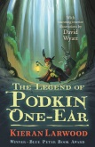  Reading: Continue to read a chapter of ‘The Legend of Podkin One-Ear’ each day with an adult. You can download a copy onto the kindle app or access the text in teams. | Literacy: Podkin has one of twelve magical Gifts - a sword that can cut through anything except iron. Each Gift has a special power, but also a weakness that makes them tricky to use. Can you design your own Gift with its power and weakness? Draw a picture of what it might look like to help you. | Literacy: Write a diary entry as Lady Russet, following the escape of Paz and Podkin. What was it like to see children who weren’t yours? How did you feel about betraying Paz and Podkin? Why did you do it? What did you want in return? What do you think the Gorm has in store for you? | Literacy: As the story continues we hear the tale of how Podkin lost his ear. Read the text carefully, taking notice of the description and draw what you imagine Podkin to look like once he only has one ear. Think about how he has been portrayed by the author throughout the text and use this to design your portrait.
Literacy:  Look at the image.  Write a story about who wrote this note. Why are they saying thank you? Who have they sent it to? How did they deliver the note? What are they doing now? | Maths: Create a poster to organise all your knowledge about triangles. What are the names for the different types of triangles? What are their properties? What do all the interior angles of a triangle add up to? | Maths: Take some time this week to work out the 13, 15, 17 and 19 times tables. Memorise these tables to help with those tricky long division questions you often get in your arithmetic tests. | Maths: Use your mathematical skills to do some baking! Find a recipe to make a cake or some cookies. You could change the recipe to feed more or less people – testing your ratio skills. You will also be testing your weighing and measuring skills when you gather your ingredients.
RE: Look up this reference in your Bible: Acts 1: 6-14. This passage describes the Ascension of Jesus. Draw a picture depicting the description of the Ascension. | RE: Find out about how deacons serve in the Church today. Create a job advert aiming to recruit a deacon in your local parish. Consider what qualities deacons need, what would be expected of them etc. | History: Research the Spanish Armada which occurred during Elizabeth I’s reign. Write a recount of the events and how this impacted on Elizabeth I’s reign. | Science: Research magnetic forces and magnetic meteorites. Create a resource to teach others about what you have learnt, this could be as a video, a comic strip or a fact file.
Spellings: Find 10 word that use the suffix ‘ful’. Learn to spell these.  Check your SpellingShed page too. | PE: Practise moving around a grid with several obstacles laid out using items found around your home. Use different footwork patterns to move through the obstacles. Use the ideas below to make the activity more or less challenging:  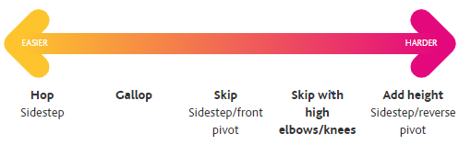 | Art & Design Technology: Design and create a replica of an Elizabethan galleon. Use a range of recyclable materials from around the home (egg boxes, cardboard, lolly sticks etc) to build your galleon. Challenge: can you make your galleon float? | Wellbeing: Create a playlist of your favourite feel-good songs. You can use YouTube for inspiration and save your songs into your own playlist. Turn your music up loud and dance along to your playlist whenever you’re feeling a little blue.
https://theday.co.uk/subscriptions/the-day-home Ask an adult to register for this daily newsletter. Use it daily to guide a family debate.

