Year 6 Home-Learning grid if you do not have access to Microsoft 365 Teams. If you have lost your details, contact the school or use the phone numbers on the newsletter.
Week commencing Monday 20th April
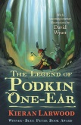  Reading: Read a chapter of The Legend of Podkin One Ear each day with an adult. You can download a copy onto the kindle app or access the text in teams. Collect a word bank of any interesting similes, personification, metaphor and phrases used. | Literacy: Look at the map from the start of the book. Find two of the places mentioned: one that sounds nice and one that sounds dark. Write a description about what each places might be like. E.g. Dark Hallow and Apple Cross. | Literacy: Look at places names around England using a map. Did you notice that names of places end in the similar suffixes? What do these place endings mean: hurst, by, wick, ton, stead, field, ford, bury. (Use a dictionary to help you.) Make up some fictional place names of your own, using the suffixes. |  | Art: Learn how to draw a rabbit.  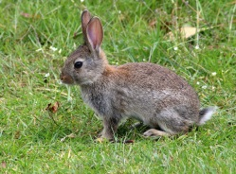
Maths:  How do you measure angles using a protractor? How do you draw a triangle using a protractor?  Please teach me!!!  Design a tutorial to help someone learn how to use a protractor accurately. | 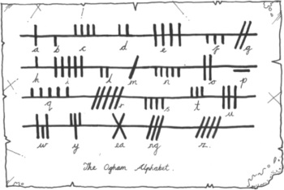  Literacy: Podkin, Paz and Pook’s mum sent a letter using an ancient alphabet system that she knew would make the letter hard to read. Create your own alphabet system. Write a short message in English and then copy this using your own alphabet system. | Literacy: In the story so far, we have heard of two feasts being celebrated: Bramblemas and Mer Day. Using your knowledge of different feasts and festivals around the world, and how these are celebrated, create your own fictional feast day. Look back at the ones in the story so far to help you plan yours. Then write up an information text about how it is celebrated, what we do etc. More information is on teams. |  | RE: Witnesses: Can you think of something that you witnessed? Maybe you saw a friend being treated unfairly. What did you do when you witnessed this? Do you react in the correct way? What could you have done differently?  Write a recount of those events making sure that you include the above questions.
RE: Write a prayer of thanks for all of the wonderful people in your life, in our community and in our world. Remember a prayer can be a letter or a poem to God. | Spellings: Find 10 word that use the prefix ‘auto’. Learn to spell these.  Check your SpellingShed page too. | History: Who was Elizabeth I?  Carry out some research on this Tudor queen. https://www.natgeokids.com/uk/discover/history/monarchy/elizabeth-i-facts/  Record your learning appropriately - as a recount, report, two page spread
https://theday.co.uk/subscriptions/the-day-home Ask an adult to register for this daily newsletter. Use it daily to guide a family debate. | PE: Log onto YouTube and complete the daily dance routines taught by Oti Mabuse or make up your own dance routine. | Maths: Create a poster for your 12 x tables. Try to make it 3D! You could include derived facts like  1.2 x 3 = 3.6 and 144 ÷ 12 = 12 | RE: How would the disciples have felt when Jesus reappeared after his resurrection? Record how they felt and what they said in a report, diary, recount – however you wish.

