Week commencing Monday 4th May

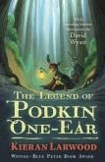  Reading: Continue to read the next chapter of ‘The Legend of Podkin One-Ear’ each day with an adult. You can access the text via Team or on the Kindle app. | Literacy: Create a villain/baddie. What are the features about them that make them bad? Your villain could be inspired by the Gorm. The Gorm have “spiked iron shoulders” and “voices like metallic screeching”. | Literacy: Within the mythical land you have created, now think about the creatures that live there. Draw and describe them.  In Podkin, rabbits live in warrens with hundreds of rooms. Describe the different places your creatures can go. | Literacy: Write a persuasive advert for an Elizabethan house. The aim of the advert is to persuade someone to buy the house. Keep the reader interested, use impressive adjective and other devices like rhetorical questions. Remember to keep to the point!
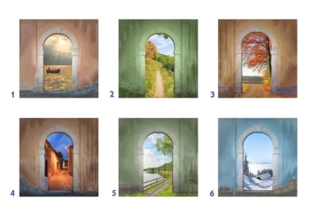  Literacy: Pick a door. Write a short story. This is an opportunity to be creative! Describe the door. Think: why did you pick it? Where does it take you? What can you see? Do you meet anyone? Think about your senses: what can you smell, taste, hear, see and touch? | Maths: Time to think about your squared and cubed numbers. Begin to learn these numbers. You could draw a grid up to 100 and colour the squared numbers in one colour and the cubed in another. | Maths: Find a piece of furniture, like a table, a television or a cabinet. (Something easier and straight) It could even be the patio or a wall outside.  Measure it to find the perimeter and area of this piece. As you can confidence, why not try a complicated piece like a chair. | Maths:  Word Challenge!  You are planning a feast for Elizabeth I. She has invited 420 people. For the meat course, one leg of mutton (lamb) is enough for 3 people.  How many legs of mutton will you need?  Friday is VE Day. Plan a VE Day afternoon tea for your family. Bake some scones and make some finger sandwiches. What is the cost of the afternoon tea? What would it cost you to have afternoon tea at a posh hotel? What is the difference in cost?
RE: Use your Bible to look up Acts 16: 11-15. Write a diary entry as if you were Lydia. How did you feel when listening to Paul’s message? How did following Jesus affect her life and her business? | RE: Modern witnesses to the Holy Spirit: Research Mrs Maricho, a teacher in Natandol, Philippines. How is she a witness to the Holy Spirit? | History: Research VE day. What is it? Create a poster or fact file with your information. You need to inform someone as if they have never heard of VE day. Create a victory flag. | Science: Research moons in our solar system.  Can your get creative and create some moons with objects around the house?
Spellings: Find 10 words that end with the suffix ‘-ible’. Learn to spell these words. Get an adult to test you. | PE: Remember to stay active during this time. Follow this Just Dance routine https://www.youtube.com/watch? | Art & Design Technology: Still life drawing - draw a 3 dimensional apple https://www.youtube.com/watch?v=LdmqR2qwCYo Why not challenge yourself after and draw another item of fruit from around the house. | Wellbeing: Write down 5 things you are grateful for!  You could do this alone or with a sibling or adult. Share ideas. Decorate the page. Take the time to slow down.
DEBATE TIME
Is it good to be famous?
Think about the lavish lifestyle. What about the constant attention. Could it get too much? Has it helped to be famous during lockdown? Are they really that important in the world?

