HISTORY  Watch this film clip  https://www.bbc.co.uk/teach/class-clips-video/true-stories-florence-nightingale/z68fcqt  Write a fact file about Florence Nightingale. Think about her long- lasting influence on nursing today. | ART  Spring is definitely here. Look around you for evidence of this season. Create a collage showing this new life. Try to use a variety of resources to represent this growth from nature. Look carefully at the colours and shapes that you see. Take a pic and send it to us!  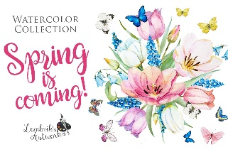 | RE  Retell the Easter story from the point of view of a disciple. Think how they would have felt seeing their best friend suffering. Start from Palm Sunday, when Jesus rode into Jerusalem and was greeted with the waving palms  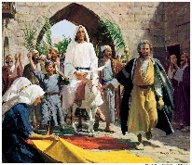 | LITERACY  Let’s get writing? Create an adjective poem. It can be any style; rhyming, acrostic, free verse etc. It can be funny or serious. See how many adjectives you can squeeze in. Don’t forget you can always use a dictionary and thesaurus to help you with your spellings and to uplevel your choice of adjective!  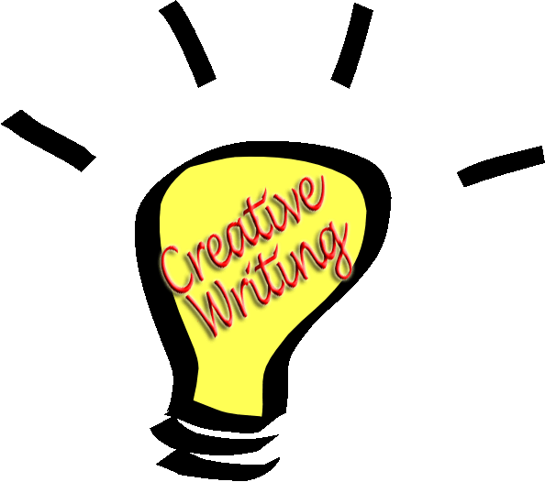
MATHS  Create your own board game based on times tables. It can have chance cards etc to make it more exciting. Make sure your times tables knowledge is correct!  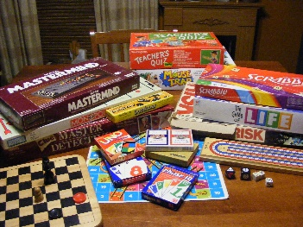 | SCIENCE  Go on a leaf hunt. Find the name of the tree and research about it. How tall does it grow? How does it reproduce? What animals does it provide a habitat for? Create a colourful poster detailing the information that you have found. | GEOGRAPHY  Design a plan of the road you live in. Remember plans are from a bird’s eye point of view. Have a good look at what street furniture you can see e.g. street lamps, benches etc and create a key to represent these. | MUSIC  Get creative and create your own musical instrument. It could be a shaker type, a drum or a stringed instrument. Remember to take a pic. Then write adjectives to describe the sound and tone.  