Week Commencing Monday 8th June
Reading:  Find a book that you enjoy reading at home and spend a few minutes each and everyday reading parts of the story. At the end you can create a book review about the story. | Literacy:  Look around your house to see if you can find any news papers lying around. What can you see are the same or different about their layouts? What do they all have in common? How are they different? | Literacy:  Linking with what you have noticed from looking at various newspaper articles, can you create your own newspaper article? What will your headline be? Will you include and image? How will your article start? | Art:  Collage time. Make a collage using cutouts from various newspaper or magazines that you might have lying around the house.
Literacy:  Mr Jawandha is becoming a bit of a talent for youtube but he still needs to pick up a few points on where to improve.  Watch one of Mr Jawandha’s videos and then write a letter critiquing it.  - What does he do well?  - How could he make it better?  - What would you like to see him do? | Maths:  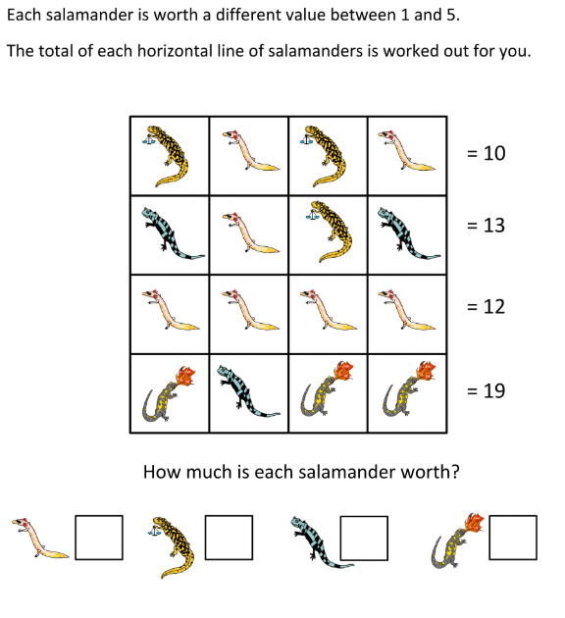 | Maths:  Telling the time is a very important life skill. If time is something you know you struggle with then it is time to get learning.  Find a clock in your house and an adult. Ask them to help you. Begin with terms like o’clock and half past, then quarter past and quarter to.  Good luck! | Maths: Word Challenge!  Time to learn some lovely Time:  Mr Rooney leaves for work at 7:30am. It takes him 35mins to drive to work. What time does Mr Rooney arrive at work?  On Tuesday Mr Rooney leaves at 7:30am but gets a puncture as has to walk to work. He arrives at work by 8:25. How long did it take Mr Rooney to get to work?
RE:  People are witnesses to their faith by working in the community. With all that is going on in the media at the moment about racial injustice and racism, how can we as people of god show that we are there for others who have suffered from racism? What could you do as a servant of god to better educate yourself on racism? | TWITTER:  Keep up to date on St Anthony’s Twitter page!  Lots of your pictures are on there, plus you get to see what the other year groups are up to. | History:  Back in roman times, take away were a thing. People could go and order hot food from take away because many did not have access to a cooker or other material to cook food on. A favorite was pizza made with onions, pickles, fish and ham. Tomata paste didn’t become a thing until later. Can you make your own modern pizza? | Science:  Building a rain catcher. In some parts of the world, water Is hard to come by. Can you design and make a rain catcher that you could use?
Spellings: Find 10 words that start with the prefix –re. Learn to spell these words. | PE:  Throughout this week take on the odds and even challenge  On odd numbered days:  - 20 Jumping jacks  - 10 Heel flicks  - Hold a plank for 20 seconds  - 10 Squat jumps  On even numbered days:  - 10 Burpees  - 20 Mountain Climbers  - 10 Squats  - 20 Bunny Hops | Art & Design Technology:  Hands up, who is missing Maccy D’s?  Well in the hopes of MC D’s opening when it is safe, have a go at making your very own home-made burgers :D  - 500g minced beef (Mr Rooney would recommend steak mince for this, leaner mmm)  - 3 spring onions  - 2 cloves of garlic  - 1 tsp of paprika  - 1 tsp dried parsley  - Pinch of black pepper | Wellbeing:  Go outside. Whether that be in your back garden or on your daily walk.  Look up!  Look at the sky, watch the clouds. Can you spot the patterns of the clouds? Draw a picture of the different shapes and their sizes.
WORRIES:
We all have worries (yes, even your teachers) and that is OK!

Write them down! Share them! It is good to talk and open up about them.

A problem shared is a problem halved 😊

