Week Commencing Monday 18th May
Reading:  Find a book that you enjoy reading at home and spend a few minutes each and everyday reading parts of the story. At the end you can create a book review about the story. | Literacy:  You have been transported back to the Stone Age. Write a diary entry about your first day’s experience when you are there. | Literacy:  Create your own board game. Write instructions (detailed instructions) about a made-up game that requires a dice. | Literacy:  Out of Control! Write a short story about this picture.  What vehicle is the driver operating?  What might he have seen in front of them?  What is the weather like outside?  where might they be going?
Literacy:  Mr Jawandha is becoming a bit of a talent for youtube but he still needs to pick up a few points on where to improve.  Watch one of Mr Jawandha’s videos and then write a letter critiquing it.  - What does he do well?  - How could he make it better?  - What would you like to see him do? | Maths:  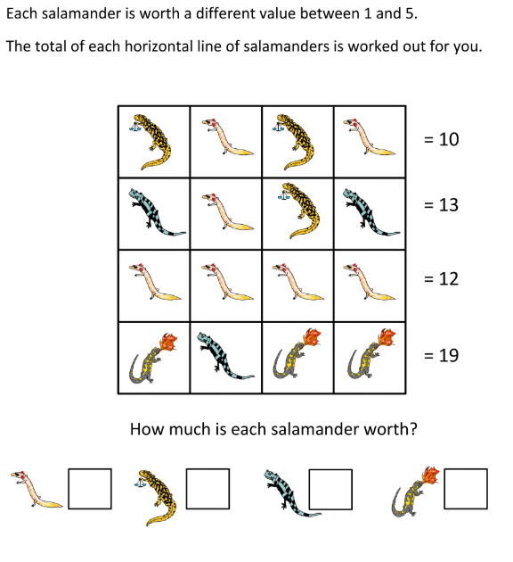 | Maths:  Telling the time is a very important life skill. If time is something you know you struggle with then it is time to get learning.  Find a clock in your house and an adult. Ask them to help you. Begin with terms like o’clock and half past, then quarter past and quarter to.  Good luck! | Maths: Word Challenge!  Time to learn some lovely Money:  apple = 10p  Banana = 20p  Crisps = 55p  Mr Rooney goes to the shop and puts 2 apples, 3 bananas and a packet of crisp in his basket. How much is everything in his basket worth?  Mr Rooney has £1. How much more does he need?
RE:  People are witnesses to their faith by working in the community. Write about a local charity.  1). Who founded it and why?  2). What was their inspiration, how do they help people  3). Explain what a difference it makes.  Suggested charities:  SHOC (Slough Homeless Our Concern), Slough Outreach, Slough Refugee Support, Thames Valley Hospice | TWITTER:  Keep up to date on St Anthony’s Twitter page!  Lots of your pictures are on there, plus you get to see what the other year groups are up to. | History:  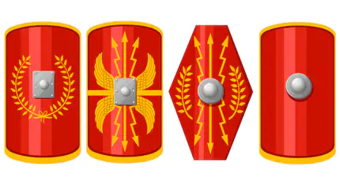  Design a Roman shield that the ancient warriors would have used when going into battle. Have fun with the decals on the front, be inventive. | Science:  Building a rollercoaster. You can use anything! Look around the house for pipes, straws, toilet rolls etc. Your recycling would be a great start.  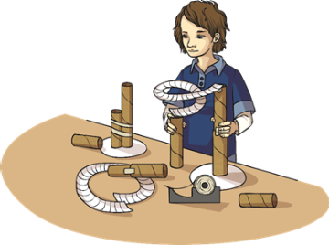
Spellings: Find 10 words that start with the prefix –un. Learn to spell these words. | PE:  Throughout this week take on the odds and even challenge  On odd numbered days:  - 20 Jumping jacks  - 10 Heel flicks  - Hold a plank for 20 seconds  - 10 Squat jumps  On even numbered days:  - 10 Burpees  - 20 Mountain Climbers  - 10 Squats  - 20 Bunny Hops | Art & Design Technology:  Hands up, who is missing Maccy D’s?  Well in the hopes of MC D’s opening when it is safe, have a go at making your very own home-made burgers :D  - 500g minced beef (Mr Rooney would recommend steak mince for this, leaner mmm)  - 3 spring onions  - 2 cloves of garlic  - 1 tsp of paprika  - 1 tsp dried parsley  - Pinch of black pepper | Wellbeing:  Go outside. Whether that be in your back garden or on your daily walk.  Look up!  Look at the sky, watch the clouds. Can you spot the patterns of the clouds? Draw a picture of the different shapes and their sizes.
WORRIES:
We all have worries (yes, even your teachers) and that is OK!

Write them down! Share them! It is good to talk and open up about them.

A problem shared is a problem halved 😊

