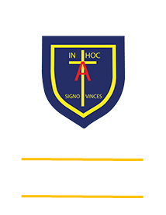
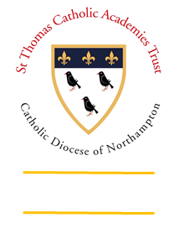
St. ANTHONY’S CATHOLIC
PRIMARY SCHOOL & NURSERY
In the Diocese of Northampton

Head Teacher: Mrs S Oppé, LLB, MA
Farnham Rd, Farnham Royal, Slough, Berkshire SL2 3AA
Tel: 01753 645828 | Email: post@stanthonys.slough.sch.uk

Learning, Growing
And Living with Jesus
“The glory of God is
a human being fully alive”

Year 3 home learning – week commencing 27th April 2020
Art  Create a DIY marble/pea maze using toilet roll tubing  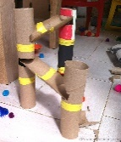 | Research  Look up the ancient tribe the Iceni. Create a fact-file about them. | Maths  Create a game or activity to help you learn your 4 times tables.  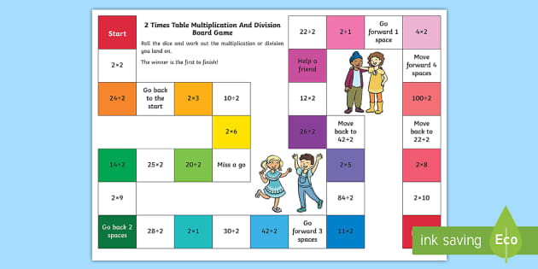 | English  Create a diary entry for a child in the Iron Age.
Science  Solve a problem using critical thinking skills. Paper plane wings  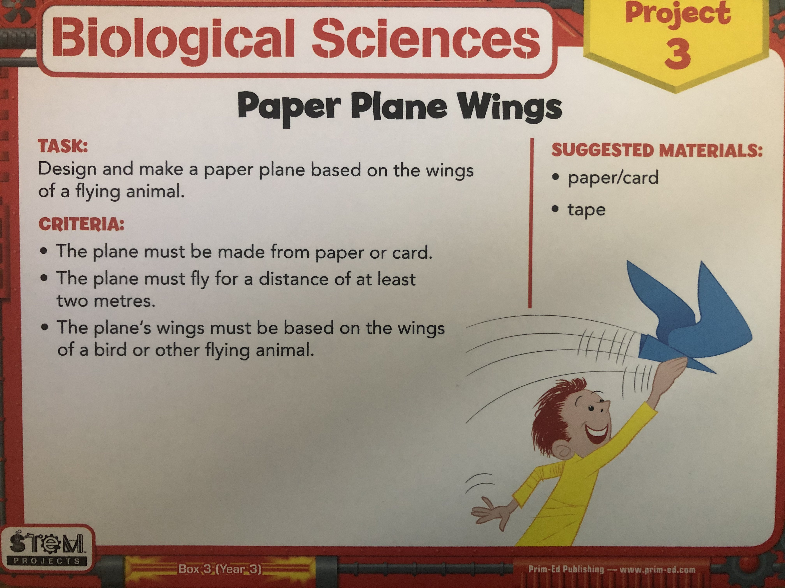 | Geography  Create a map of the key features of India.  Longest river  Tallest mountain  Main mountain range  Largest cities  Rainforests  Deserts | RE  Create a prayer for those around the world during this difficult time. | Music  Using rice and some materials, try and make a homemade guitar.  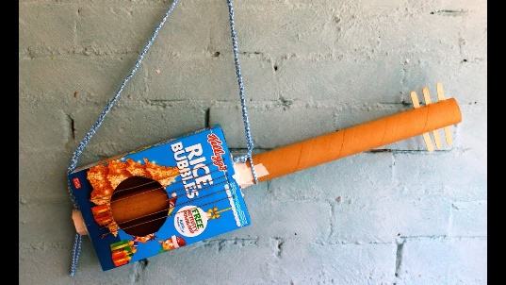
Remember to constantly challenge yourself. Can you do better?

