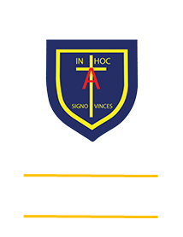
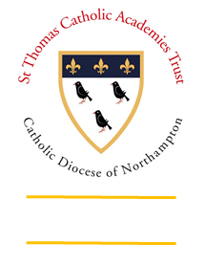
St. ANTHONY’S CATHOLIC
PRIMARY SCHOOL & NURSERY
In the Diocese of Northampton

Head Teacher: Mrs S Oppé, LLB, MA
Farnham Rd, Farnham Royal, Slough, Berkshire SL2 3AA
Tel: 01753 645828 | Email: post@stanthonys.slough.sch.uk

Learning, Growing
And Living with Jesus
“The glory of God is
a human being fully alive”

Year 3 home learning – week commencing 20th April 2020
Art  Create a side profile portrait of a family member or even a piece of fruit or vegetables.  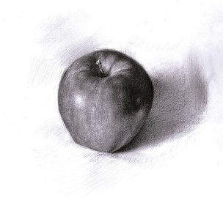 | Research  Look up the ancient civilisation of the Celts. Create a two-page spread about them. | Maths  Create a game or activity to help you learn your 3 times tables.  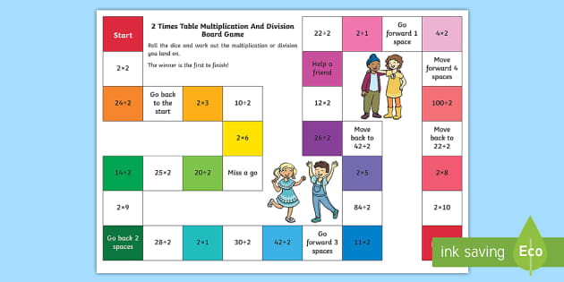 | English  Create a biography of Queen Boudica.
Science  Using a cardboard bow or container, design a maze for a potato to grow its roots from  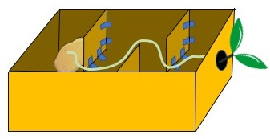 | Geography  Using a map, locate the location of the Iceni tribe during the Celtic time period.  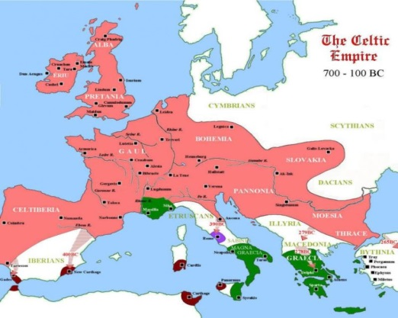 | RE  Research St. George, who was he and what he did.  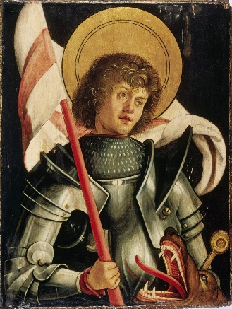 | Music  Using rice and some other materials, try to make a rain shaker.
Remember to constantly challenge yourself. Can you do better?

