Week beginning 20th April 2020 St Anthony’s Year One weekly timetable of work
Topic: Wild Animals and Habitats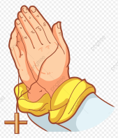
Please log into Purple Mash and complete the 2Do tasks on there as well. Send them back to us so we can see what lovely work you have been doing. I wonder how many rewards you can earn on it as there’s lots to achieve. Below are all of the rewards you can earn. Try and earn them all!
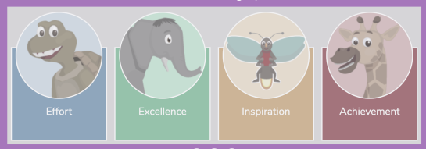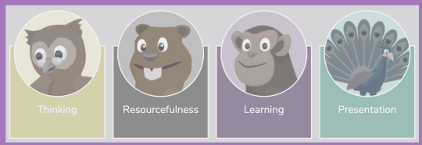
Try and complete the maths and literacy activities in the morning and leave the RE, Science and Creative for the afternoon.
MONDAY | TUESDAY | WEDNESDAY | THURSDAY | FRIDAY
Start each day with a prayer:
Father in heaven, you love me,
you are with me night and day.
I want to love you always in all I do and say.
I’ll try to please you Father, bless me through the day.
Amen
10 mins of exercise each day - either Joe Wicks or do 10 star jumps 10 stretches to the ceiling, 10 stretches to touch the floor with your hands flat on the table, 10 hops on either leg
10 mins of reading each day – you can read a story you have got in your school bag, books you may have from the library or books you have at home. You are able to read parts of a story yourself now so please make sure you put time aside each day to do this. If you need an adult to help you with reading, find a time when they are available to help you. If you have an older sibling in your house, maybe they can sit and read with you too.
Maths  Today we are practising the days of the week.  Click on the link below and sing along to the days of the week song.  https://www.youtube.com/watch?v=mXMofxtDPUQ  Ask a grown up to write out the days of the week. Then cut them out and put them in the right order.  - What day is it today?  - What day was it yesterday?  - What day will it be tomorrow?  Challenge: Can you learn the months of the year? | Maths  Put these times of day in order.  - Evening  - Midday  - Afternoon  - Morning  Draw a picture to show what you do during each part of the day.  Challenge:  Can you draw a clock face to show your favourite time of day? | Maths  Counting in 5’s is an important skill to have when we’re learning to tell the time.  Click on the link below to practise.  https://www.youtube.com/watch?v=EemjeA2Djjw  How long do you think a minute is?  Ask a grown up to time a minute. Close your eyes and open them when you think a minute has passed.  How did you get on?  Challenge:  Find out how many...  - Seconds are in a minute.  - Minutes are in an hour.  - Hours are in a day. | Maths  Active time challenges;  How many of these can you do in one minute?  - Hops  - Star jumps  - Skips  Find out how long it takes you to:  - Go for a walk.  - Have a drink.  - Watch your favourite programme.  - Eat your lunch. | Maths  Today you are in charge of keeping track of the time it takes your lunch or dinner to cook.  Look at a clock and ask your grown up how long it will take your food to cook in the oven.  Where will the long hand (the minute hand) and the short hand (the hour hand) be when your meal is ready?  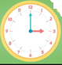
10 mins of exercise  Put some music on and dance!  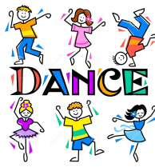 | 10 mins of exercise  Throw and catch a ball with someone in your family.  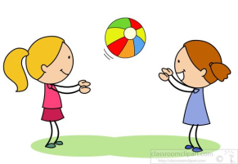 | 10 mins of exercise  Put some music on and dance!  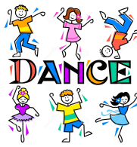 | 10 mins of exercise  Throw and catch a ball with someone in your family.  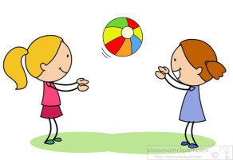 | 10 mins of exercise  Put some music on and dance!  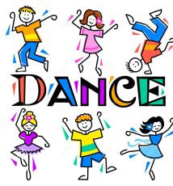
Literacy  Write about the picture below.  Think about all the magical reasons as to how and why this banana is so much bigger than the boy! How did it turn so big? What might have happened to make it this big? What might happen if the boy eats the banana? Be creative with your writing. Try and write a small paragraph to explain what might have happened.  Challenge: Can you think of 10 different adjectives to describe this banana? | Literacy  Create your name.  Can you think of fun ways to create your name and decorate it with paint/ chalk/ pencil colours? Please only use what resources you have available in your house. 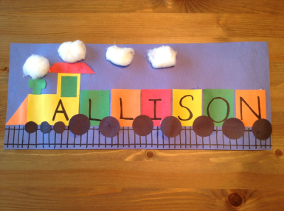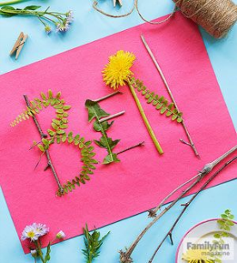  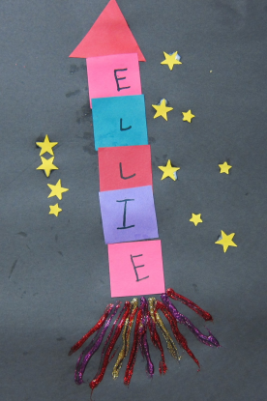  Challenge: Can you create your surname as well? Practise spelling your full name using joined up letters. | Literacy  Today, you can choose which picture you would like to write about. Don’t forget to use:  - Capital letters  - Finger spaces  - Full stops  - Adjectives  - Connectives  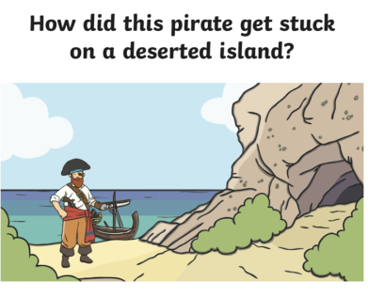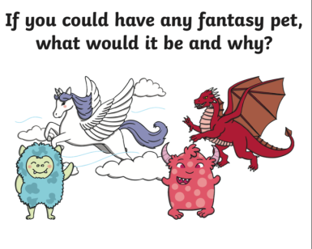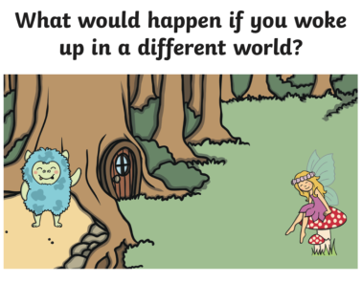  Challenge: Can you edit one sentence from your work and make it better? Maybe you can add an adjective in it? Can you add connectives to make it longer? | Literacy  Create a fact file about wild animals.  Use the internet to find out 3 facts about a tiger. What can they do? What do they eat? Where do they live?  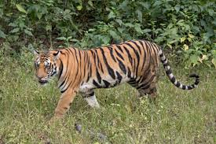For example:  Tigers eat meat and flesh. They are carnivores. They are orange with black stripes. Tigers have a long tail and two pointy ears. They live in the wild and hunt for food themselves.  Challenge: Can you draw a picture of your tiger and add in some of your facts in your drawing. E.g. Where they live, their food they eat, their family... Now you can colour it in. | Literacy  Create a fact file about wild animals.  Use the internet to find out 3 facts about a giraffe. What can they do? What do they eat? Where do they live? Why do they have such long necks?  Challenge: Can you read out the fact file you have made to a member of your family? Tell them wat you have learnt about tigers and giraffes this week.
RE  Our new topic is ‘Holidays and Holy days’  Have you been on holiday? Where did you go? Who did you go with? What was it like? What did you take?  If you have holidays at home what are they like? How are the different to the days you spend at school?  Can you make a list of things that you like to do in holiday time?  Maybe you have some holiday photographs you could look at? | Science  Click on the link below and learn more about what is an herbivore, carnivore and omnivore:  https://www.bbc.co.uk/bitesize/topics/z6882hv/articles/z96vb9q  You can find extra videos to watch and learn about this on YouTube as well.  Can you explain what these words mean to an adult in your house? They will be very impressed when you can explain these big words. |  | Creative  Can you create your own tiger using items around your house? You can colour it in or paint with the items you have available in your house.  