Week beginning 18th May 2020 St Anthony’s Year One weekly timetable of work
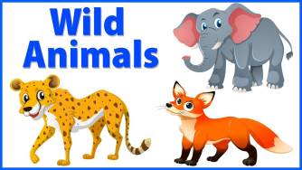Topic: Wild Animals and Habitats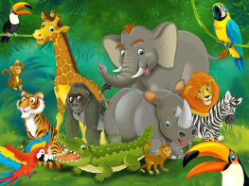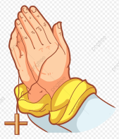
Please log into Purple Mash and complete the 2Do tasks on there as well. Send them back to us so we can see what lovely work you have been doing. I wonder how many rewards you can earn on it as there’s lots to achieve. Below are all of the rewards you can earn. Try and earn them all!
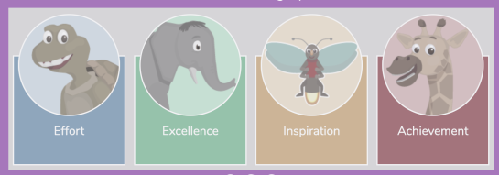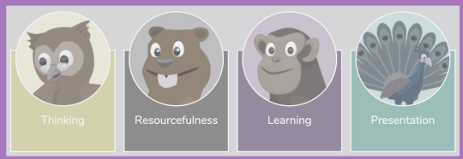
Try and complete the maths and literacy activities in the morning and leave the RE, Science and Creative for the afternoon.
Please do send us photographs via the email addresses provided as we would love to see the children’s creations. We can’t wait to see what wonderful work you have been up to at home.
Mrs Chavda (1 Joshua) achavda@stanthonys.slough.sch.uk
Miss McBrearty (1 Ruth) hmcbrearty@stanthonys.slough.sch.uk

MONDAY | TUESDAY | WEDNESDAY | THURSDAY | FRIDAY
Prayer
God in heaven hear my prayer.
Keep me in thy loving care.
Be my guide in all I do.
Bless all those who love me too.
Amen
10 mins of exercise each day - either Joe Wicks or do 10 star jumps 10 stretches to the ceiling, 10 stretches to touch the floor with your hands flat on the table, 10 hops on either leg
10 mins of reading each day – you can read a story you have got in your school bag, books you may have from the library or books you have at home. You are able to read parts of a story yourself now so please make sure you put time aside each day to do this. If you need an adult to help you with reading, find a time when they are available to help you. If you have an older sibling in your house, maybe they can sit and read with you too.
Maths  Exploring capacity  Capacity means how much a container can hold. A container could be a cup, a bowl, a box, a bucket... anything that can hold something in it.  Today we are going to be measuring the capacity of a bucket using cups of water. (It doesn’t have to be a bucket, you can choose which container).  You will need need a bucket (like you’d use to make a sandcastle), a bigger container with water in it and a cup.  You might get wet. If you can’t do this outside you could do it in the bath or a basin by putting your bucket in and filling it up with cups of water from the tap.  Ask a grown up to make a tally chart of how many cups it takes you to fill up the bucket with water.  Then, add up your tally, how many cups did it take to fill the bucket?  Challenge:  Find out some of the different things we can use to measure liquid.  What unit of measure do we use for liquids? | Maths  Capacity  Today you’ll need water, a plastic bottle and a jug.  Fill up the jug with water (you could add squash or food colouring to make it more exciting), then pour the water from the jug into the bottle.  What has happened?  Did it overflow or did the bottle have a big enough capacity to hold all the water?  Does the jug or water bottle hold more water?  This time fill the jug with the water from the bottle.  Make a prediction. What do you think will happen?  Next, collect some different containers e.g. yogurt pot, jug, ice cream tub, shampoo bottle, milk bottle...  This time we’re going to measure how many cups of water it takes to fill different containers. Keep a tally chart to help you remember how many cups it took to fill each container.  Hold onto your tally chart, you’ll need it again tomorrow. | Maths  Bar chart  Today we are going to use the tally chart you made yesterday to make a Bar Chart.  A bar chart is a way of showing information that easily shows what you found out.  Here is an example about fruit. We can quickly see that bananas were the most popular and apples were the least popular.  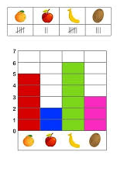  With help from a grown up draw up your own bar chart (or see below for instructions on how to do this on Purple Mash).  The different containers need to be at the bottom. You need to write numbers starting at 0 up to the highest amount of cups it took to fill up each container.  When you have drawn each bar you can colour each one a different colour.  Purple Mash  In the search box enter 2graph.  When you’ve opened 2Graph, there’ll be a table on the left.  Where it says item type in the different containers you used.  Where it says number type in the number of cups it took to fill the container and don’t forget to choose a colour.  Challenge  Make up some questions that someone could answer by looking at your bar chart. E.g. How many cups of water did it take to fill up the jug? | Maths  Weight  Weight is about how heavy or light an object is.  Look around your home and choose 5-8 objects that you can arrange in order from the lightest to the heaviest.  While you are doing this think about:  Whether small objects weigh less and large objects weigh more.  Can you hold one object in each hand and weigh them up?  Is anything heavier/lighter than you think?  Challenge:  Can you help your grown up to weigh out the ingredients for today’s lunch or dinner? | Maths  Length  Today we’re going to be measuring the length of different objects.  When we’re measuring we have to make sure that we’re using something that is the same size to measure with.  The first thing to do today is to choose one thing that you have a lot of to measure with. This could be Lego/Duplo bricks (all the same size), paperclips, straws, crayons...  Next, look around your home and choose 5 objects to measure the length of. E.g. book, shoe, toy car, doll, cuddly toy etc...  Use the same object to measure it each thing with.  Write down the objects you have and how many paperclips/bricks/crayons long they are.  Challenge:  Find out what unit of measure we usually measure the length of objects with.  Why do you think it’s important to have one main type of measurement?
Keeping Active!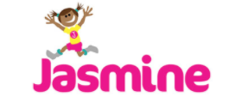
We now have free access to online PE lessons and games. Use this website to log on. There’s lots of fun activities for each week on here.
The website is: https://home.jasmineactive.com/
Username: parent@stanthonys-2.com
Password: stanthonys
Literacy  This weeks literacy is based on free online lessons provided by The National Academy. You will need a piece of paper, a pencil and an adult to help you pause the videos at the correct time.  You will have a phonics lesson during this time as well. This same format will continue all week.  Lesson 1  Sam’s Sandwich  https://www.thenational.academy/year-1/english/sams-sandwich-year-1-wk1-1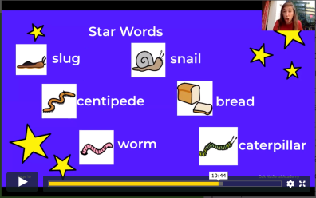 | Literacy  Lesson 2  Instructions – trying to remember them  https://www.thenational.academy/year-1/english/instructions-to-commit-a-set-of-instructions-to-memory-year-1-wk1-2  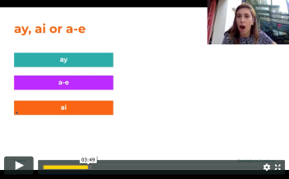 | Literacy  Lesson 3 – To use the conjunction ‘and’  https://www.thenational.academy/year-1/english/instructions-to-use-the-conjunction-and-year-1-wk1-3  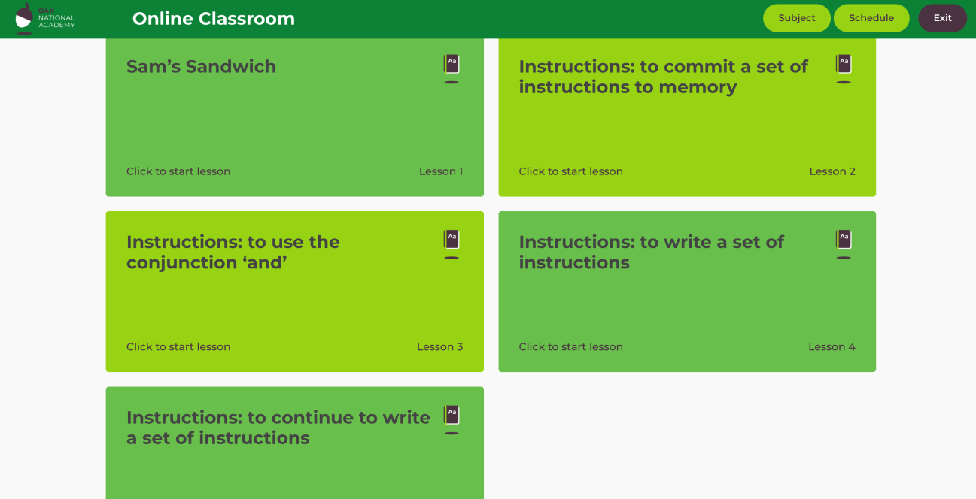 | Literacy  Lesson 4 – To write a set of instructions  https://www.thenational.academy/year-1/english/instructions-to-write-a-set-of-instructions-year-1-wk1-4 | Literacy  Lesson 5 – To continue to write a set of instructions  https://www.thenational.academy/year-1/english/instructions-to-continue-to-write-a-set-of-instructions-year-1-wk1-5
RE  Pentecost Day  What can you remember about the story of Pentecost?  Here’s the link to the story from last week if you need to recap.  Jesus’ friends knew he would keep his promise to send them a helper.  When the Holy Spirit came on Pentecost day, they shared the happiness of Jesus’ love with everyone.  - What do you like best about the Pentecost story and why?  - What change had the Holy Spirit made to the friends of Jesus?  Draw a picture showing what happened on the day of Pentecost.  Can you add thought bubbles to show what the disciples are thinking and feeling? | Science  You can have some fun with this skittles experiment. If you don’t have skittles this week at home, you can get some whenever it is possible and try this at a later date. It’s a lot of fun... watch what happens to the colours carefully! You can write these sentences on your own piece of paper and work out if ‘then’ or ‘than’ is missing.  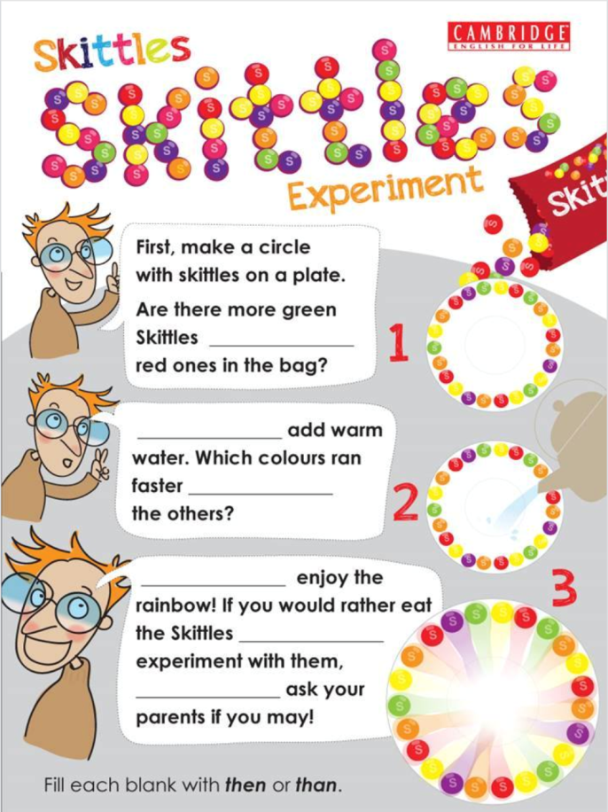  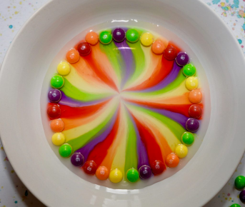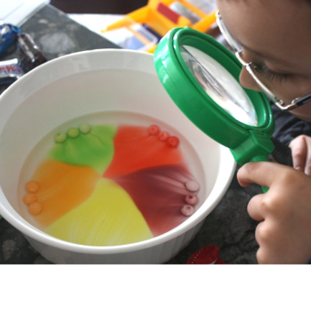 |  | Creative  See if you can collect a variety of leaves and flower petals on your walk or in your garden. Try to create a beautiful picture using them. Here is a picture of an artist who did these beautiful pieces of work during lockdown. What do you think? I think they are really amazing!  