Pentecost 2 Week 2 - 8th June 2020 Year One weekly timetable of work
Topic: 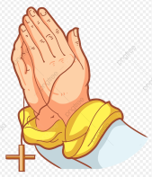
Please log into Purple Mash and complete the 2Do tasks on there as well. Send them back to us so we can see what lovely work you have been doing.
Try and complete the maths and literacy activities in the morning and leave the RE, Science and Creative for the afternoon.
Please do send us photographs via the email addresses provided as we would love to see the children’s creations. We can’t wait to see what wonderful work you have been up to at home.
Mrs Chavda (1 Joshua) achavda@stanthonys.slough.sch.uk
Miss McBrearty (1 Ruth) hmcbrearty@stanthonys.slough.sch.uk
MONDAY | TUESDAY | WEDNESDAY | THURSDAY | FRIDAY
PSHE – This week, have a think about how you feel. You can draw yourself on another piece of paper or you can draw how you feel on the paint programme on Purple Mash. Can you find someone to talk to about how you feel?
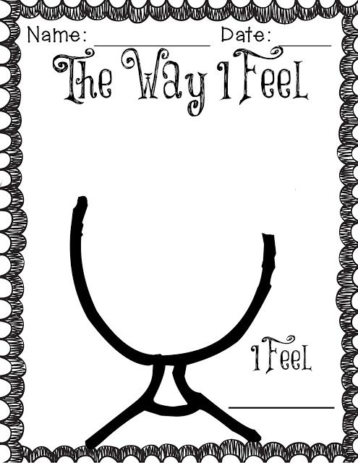
10 mins of reading each day – you can read a story you have got in your school bag, books you may have from the library or books you have at home. You are able to read parts of a story yourself now so please make sure you put time aside each day to do this. If you need an adult to help you with reading, find a time when they are available to help you. If you have an older sibling in your house, maybe they can sit and read with you too.
Maths  To recognise odd and even numbers  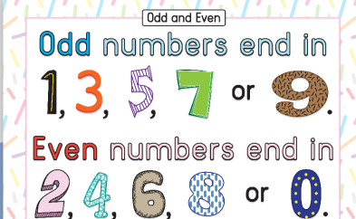Try to learn this rule above about odd and even numbers.  Split your page into two and label them odd and even.  Then using this rule, have a look at the numbers below and work out if they are odd or even.  Use these numbers and add them in the correct column: 1,5,6,13,22,29,30,25,67,55,87,29,10,46,86,49,50,100.  Challenge: Can you create the end of these number sentences so that they are correct? 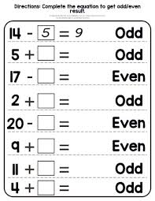 | Maths  To count in 2’s, 5’s and 10’s  You can go onto YouTube and find some excellent songs about singing in 2’s, 5’s and 10’s today. How far can you count all by yourself? You can even sing the usual ones we use in school – look for the rocket one which counts in 2’s, 5’s and 10’s! I know how much we all love these songs. | Maths  To be able to double numbers  Today, you will need a dice to play this game. Get a piece of paper and copy the numbers in the grid below. Then you can roll the dice and work out what is double that number. For example, if you roll 2 then double 2 = 4 so you need to cover up number 4 using a counter. If you don’t have counters, you can cut up small pieces of paper and use these on the numbers instead. See if you can play the game with a partner.. Who will win? Enjoy number doubles!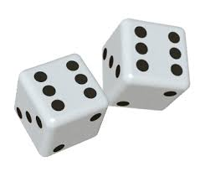 | Maths  To begin to halve numbers and solve problems  There are some problems to solve today at the bottom of this planning sheet.  You may need an adult to help you read the questions and you can use any objects in your house to help you work out the answers.  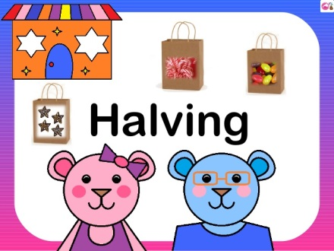 | Maths  To begin to share objects  Today you are working on the teddy bears picnic sheet which is at the bottom of this planning sheet.  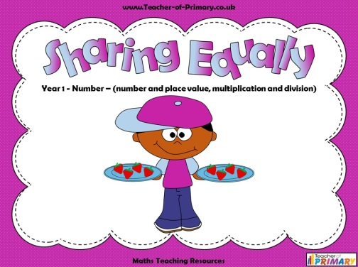  You don’t need to worry about printing the sheets out. You can just draw the answers onto paper instead.
Keeping Active!
We now have free access to online PE lessons and games. Use this website to log on. There’s lots of fun activities for each week on here.
The website is: https://home.jasmineactive.com/
Username: parent@stanthonys-2.com
Password: stanthonys
Literacy  Lesson 1  This week we will be creating a book all about Coronavirus and what you have been doing during it. This will be a booklet you can keep forever.  Think about 6 things you have loved doing at home with your family and draw a picture to explain each one.  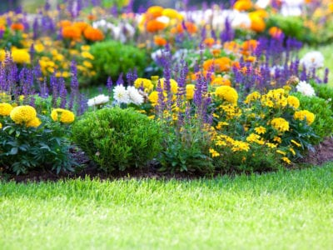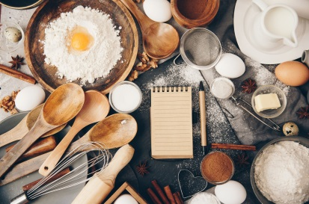 | Literacy  Lesson 2  Today, I would like you to add interesting adjectives to your pictures that you drew yesterday. For example, if you drew a trampoline you could write down ‘bouncy trampoline’ next to the picture. If you drew a bike, you can describe it and write down ‘glittery and fast bike’.  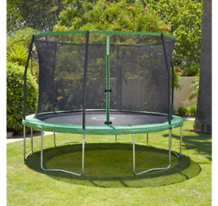 | Literacy  Lesson 3  Today, I would like you to begin writing some sentences of what you have been doing in lockdown using the pictures and adjectives you have been writing. Write 3 good quality sentences today using capital letters, finger spaces and full stops. Don’t forget to write using your adjectives as well!  E.g. During Lockdown 2020, I have been enjoying playing in my fantastic garden and I have been playing on my green, bouncy trampoline. | Literacy  Lesson 4  Write another 3 sentences today to finish off your Lockdown 2020 booklet. Use the same elements of yesterday – capital letters, finger spaces and full stops.  Maybe you’ve been reading or watching NetFlix.  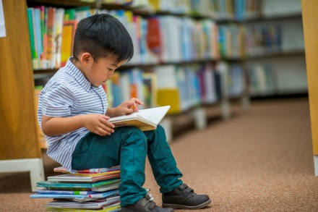 | Literacy  Lesson 5  Today you should have all the writing elements completed for your booklet. I’d like you to create a front cover for your booklet. You can even try and use bubble letters to create the front cover and make it look nicer. You can name it:  - Coronavirus 2020  - Lockdown 2020  - COVID-19 Lockdown Booklet  - Another name of your own choice  Don’t forget to write the name of the author and illustrator on the front cover as well (YOU!)
RE  We have choice, sometimes we use it well and sometimes we make wrong choices.  Sometimes we make good choices – good for others and for ourselves – and sometimes we make wrong choices which make others and ourselves unhappy.  It can be hard for us to say sorry and hard for us to forgive others when they have made a wrong choice.  Take a piece of paper and draw a line down the middle.  On one half write ‘I was happy when’ and on the other ‘I was sad when’  Draw a picture underneath of a choice that made you happy and one that made you sad. | Geography – Create a book about the UK  Use Google or an Atlas to help you label the countries in the UK.  What fun facts can you find out about England? Start to write down some sentences onto some colourful paper. We are going to make a book about the UK as the weeks go on. Be creative! I wonder how many great things you can tell me about England?  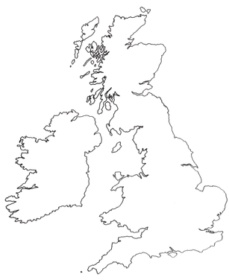 |  | CC – Weather Diary  Keep a log of what the weather is like this week. Have a look at your weather diary at the end of the week. Which day was the hottest? Coldest? Did it rain on any day?  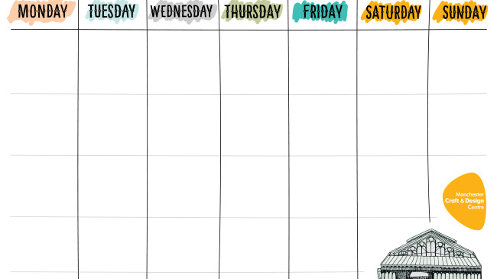
Thursday and Friday’s Maths work

