Week beginning 27th April 2020 St Anthony’s Year One weekly timetable of work
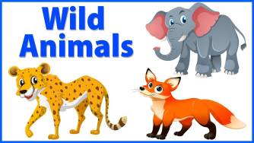Topic: Wild Animals and Habitats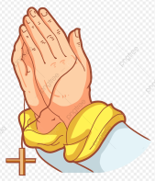
Please log into Purple Mash and complete the 2Do tasks on there as well. Send them back to us so we can see what lovely work you have been doing. I wonder how many rewards you can earn on it as there’s lots to achieve. Below are all of the rewards you can earn. Try and earn them all!
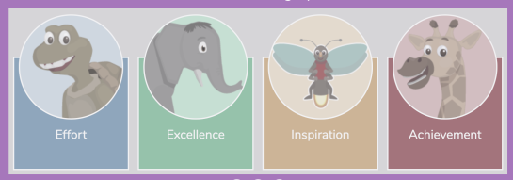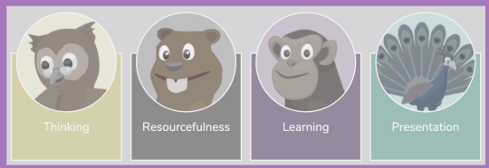
Try and complete the maths and literacy activities in the morning and leave the RE, Science and Creative for the afternoon.
MONDAY | TUESDAY | WEDNESDAY | THURSDAY | FRIDAY
Prayer
Jesus, you are good and wise. I will praise you when I rise.
Jesus, hear this prayer I send. Bless my family and my friends.
Jesus, help my eyes to see, all the good you send to me.
Jesus, help my ears to hear, calls for help from far and near.
Jesus, help my feet to go in the way that You will show.
Jesus, help my hands to do all things loving, kind, and true.
Jesus, guard me through this day in all I do and all I say.
Amen.
10 mins of exercise each day - either Joe Wicks or do 10 star jumps 10 stretches to the ceiling, 10 stretches to touch the floor with your hands flat on the table, 10 hops on either leg
10 mins of reading each day – you can read a story you have got in your school bag, books you may have from the library or books you have at home. You are able to read parts of a story yourself now so please make sure you put time aside each day to do this. If you need an adult to help you with reading, find a time when they are available to help you. If you have an older sibling in your house, maybe they can sit and read with you too.
Maths  This week we are going to be learning about money and we will be adding different amounts.  Today, find out how many British coins there are their values. Can you draw them?  Then, try out this game to help you learn to recognise coins.  https://www.topmarks.co.uk/money/coins-game  Challenge:  Which coins could you use to make 8p? | Maths  Today, set up a little shop. Look around your home and choose 4-6 items (e.g. food/toys). Then label them with a price.  Here’s an example:  2p 5p 1p  10p 20p 50p  Choose an object you’d like to buy. Which coin would you use to buy it? Can you recognise it?  You could use the coins you drew yesterday to help you.  Have a go at this game. Can you use the coins to pay for the toys?https://www.topmarks.co.uk/money/toy-shop-money  Please keep your shop open as you will need it tomorrow!  Challenge  Can you use more than one coin to pay for your item?  E.g. If it costs 5p you could use 2p+2p+1p = 5p | Maths  We are going to be practising adding two amounts together.  Label the objects in your shop with prices between 1p and 10p.  Now, choose two items and work out how much they will cost altogether. Repeat with different combinations.  As you become more confident you could increase your prices!  In this game you can practise using the coins to make the different amounts.  https://www.doorwayonline.org.uk/activities/cashing-in/cashing-in.html  Challenge:  Work out which coins you could use to pay for your items. | Maths  Counting in 2’s, 5’s and 10’s.  What number can you count to when you count in 2’s, 5’s and 10’s?  Choose a number between 1 and 5. e.g. 3  How much money would you have if you had 3 2p/5p/10p coins?  e.g. if I had three 2p coins I would have 6p altogether.  Repeat with different numbers and coins.  Can you find the hidden coins in this game?  https://natwest.mymoneysense.com/students/students-5-8/spot-the-coins/  Challenge:  Arrange the coins so that they are in order according to their value. | Maths  Today, you can design your own car! To make changes you need to pay the mechanic with the correct coins.  https://www.ictgames.com/mobilePage/customCars/index.html
10 mins of exercise  Practise your skipping skills with or without a skipping rope and then try and do star jumps. Make sure your hands and feet move at the same time. | 10 mins of exercise  Put on some happy music and dance around! Show your best moves to your adult at home. | 10 mins of exercise  Practise your skipping skills with or without a skipping rope and then try and do star jumps. Make sure your hands and feet move at the same time. | 10 mins of exercise  Put on some happy music and dance around! Show your best moves to your adult at home. | 10 mins of exercise  Practise your skipping skills with or without a skipping rope and then try and do star jumps. Make sure your hands and feet move at the same time.
Literacy:
Each day you will be creating a picture of different habitats that animals live in. Please use Google to help you are any books you might have in the house about habitats and animals. You can use any form of colours/ papers/ paints depending on what you have available in your house.
Literacy  Draw a picture and colour it in using your own colouring pens/pencils of the following habitat and draw the animals that might live there:  OCEAN  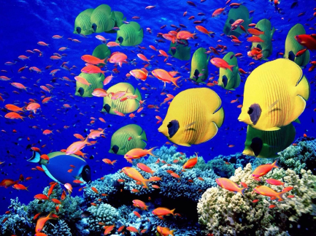  Challenge: Can you write a few sentences using ‘and’ to tell me about the animals that live in this habitat? | Literacy  Create a collage cutting out different coloured paper. Can you draw and cut out animals that live in this habitat too?  JUNGLE/ RAINFOREST  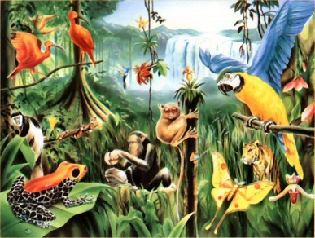  Challenge: Can you write a few sentences using ‘because’ to tell me about the animals that live in this habitat? | Literacy  Paint a picture of the following habitat and draw the animals that might live there:  SAVANNAH  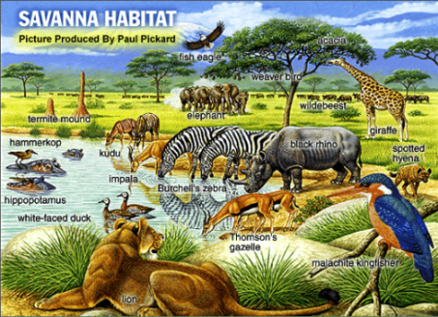  Challenge: Can you write a few sentences using at least 2 adjectives to tell me about the animals that live in this habitat?  (remember adjectives are describing words!) | Literacy  Create a picture of the following habitat and draw the animals that might live there. You can use whichever media you wish you create this. E.g. collage, painting, using chalk on the floor in your garden... be creative!  TUNDRA/ ARTIC  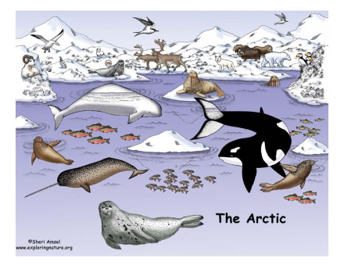  Challenge: Can you write a few sentences using the following WOW words;  furry  camouflage  to tell me about the animals that live in this habitat? | Literacy  Create a picture of the following habitat and draw the animals that might live there:  FOREST  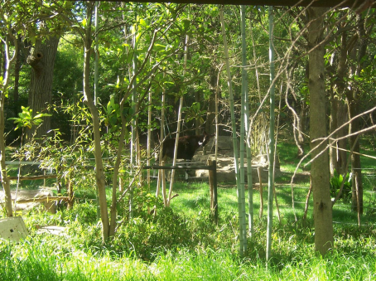  Challenge: Can you write a few sentences using capital letters, finger spaces and full stops in the correct places to tell me about the animals that live in this habitat?
RE  Our new topic is ‘Holidays and Holy days’  The word holiday comes from holyday. In the past the only holiday anyone had was a saint’s feast day or important feast days like Easter and Christmas.  Some days of the year are ‘holy days’, when we celebrate these special times in the Church’s year.  We have just celebrated Easter when we remember Jesus rising from the dead.  - Draw a picture of what you do at Christmas, Easter or St Anthony’s Day.  - Create an Easter bonnet and send us a photo back of it via email as shown below!  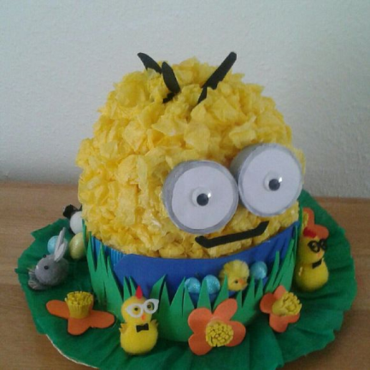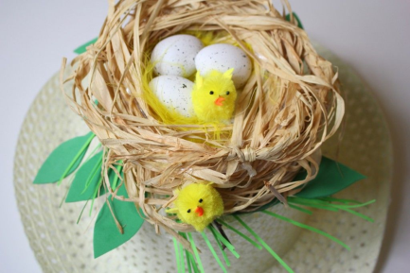  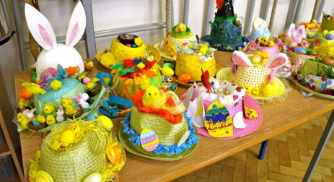 | Science  Ice experiment  Can you freeze water in the freezer to make ice? How long does it take to melt the ice naturally and adding salt sprinkled on top? Can you add a little doll or animal inside it so it is trapped? See if you can work out a way of freeing the trapped animal from the ice.  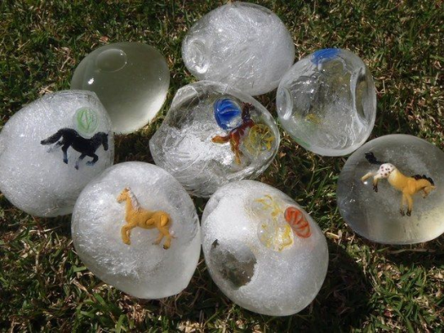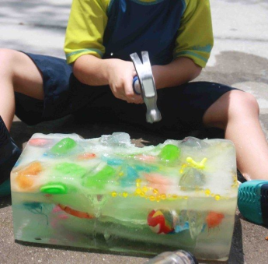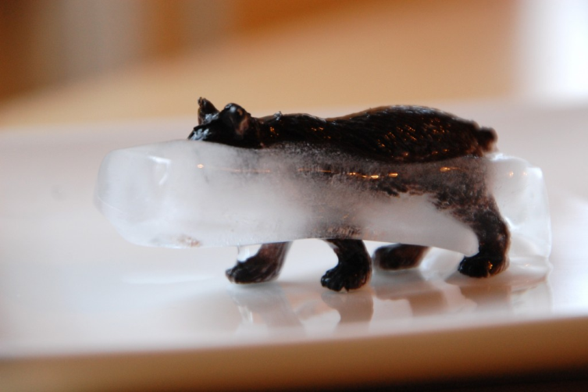 |  | Creative  How many animals can you paint using your hand prints and foot prints?  Here are some ideas below.  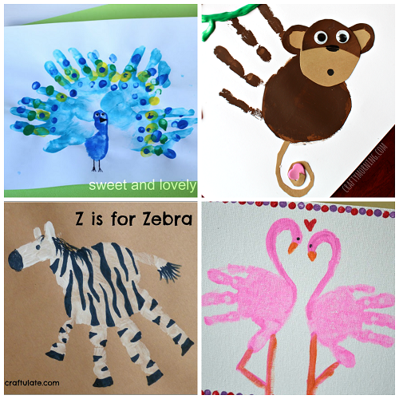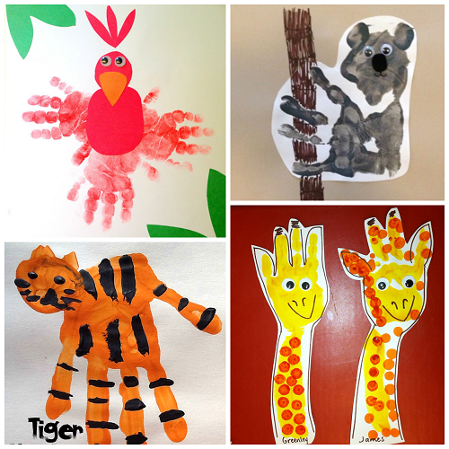  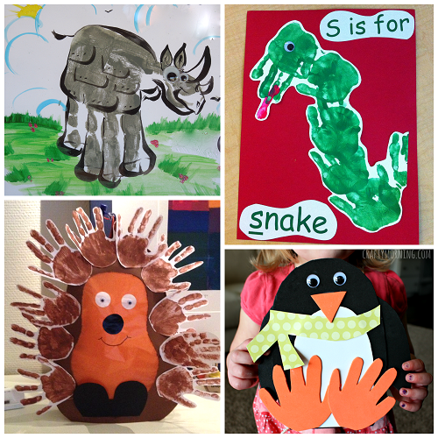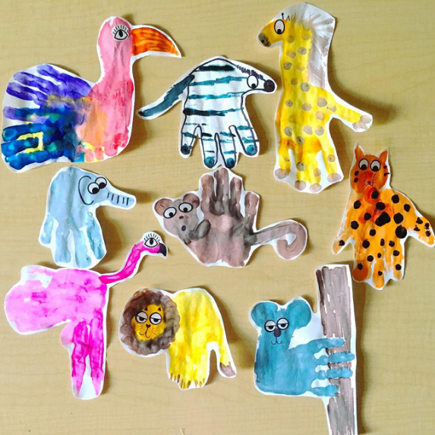
Keeping Safe
Watch the short clip about crossing the road safely. https://www.think.gov.uk/resource/crossing-roads/
When you go out remember to stop, look, listen, think every time you cross the road.
Here is a catchy song to help you remember: https://www.think.gov.uk/resource/safer-journeys-anthem/

Contact details
If you would like to send pictures of work back to us/ have any queries, please contact us via email:
Mrs Chavda (1 Joshua) achavda@stanthonys.slough.sch.uk
Miss McBrearty (1 Ruth) hmcbrearty@stanthonys.slough.sch.uk

