HISTORY  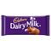  On the TV last night, Cadbury’s Dairy Milk was voted Britain’s favourite chocolate bar. What is your favourite chocolate? Research what you can find out about it and the company that makes it. Has it always been called the same? Present your findings in a poster. | ART  Andy Goldsworthy is famous for creating land art. He loves natural materials and looks carefully at the patterns and colours of nature. Have a go at creating your own. Here is an example of one of his creations.  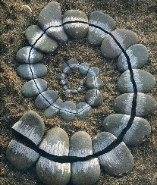 | RE  What is your favourite bible story? Read it again. Write a summary of it explaining why you like the story and what we can learn from it. Is God and Jesus trying to teach us something with this story.  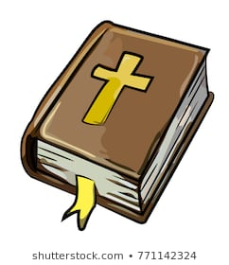 | LITERACY  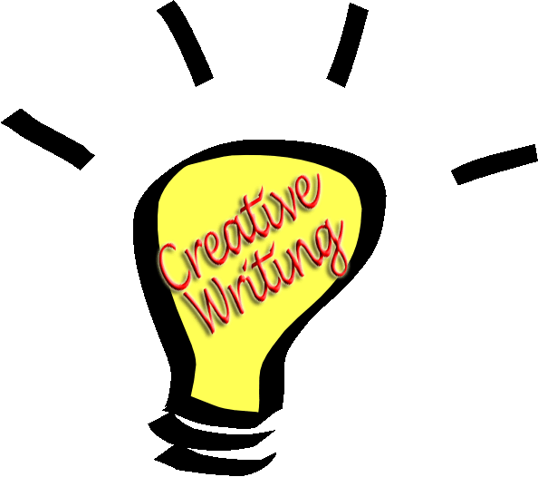  What book have you just read? How did it end? Can you write an alternative ending to the book?
MATHS  Fraction fun. What materials can you find in your home to represent different fractions? Eg. Chocolate bar. Label your fractions and then take photos (before you eat the chocolate!)  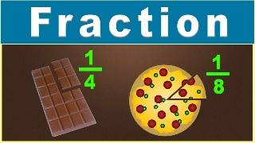 | SCIENCE  Keep a detailed weather diary for this week. Decorate your diary using the weather symbols. Compare the real weather with what is forcast either on the TV or radio. How accurate was the forcast?  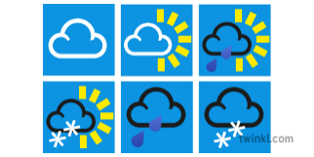 | Geography  We all know recycling is good for the planet. Do your bit! Make a useful item for the house from something that would otherwise go into the bin. Take photos and inspire others! | MUSIC  Design a back drop for the opera. That is the big picture that would be at the back of the stage. Remember it has an Egyptian theme!  