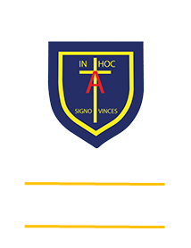
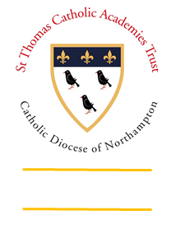
St. ANTHONY’S CATHOLIC
PRIMARY SCHOOL & NURSERY
In the Diocese of Northampton

Head Teacher: Mrs S Oppé, LLB, MA
Farnham Rd, Farnham Royal, Slough, Berkshire SL2 3AA
Tel: 01753 645828 | Email: post@stanthonys.slough.sch.uk

Learning, Growing
And Living with Jesus
“The glory of God is
a human being fully alive”

Year 3 home learning – week commencing 27th April 2020
Art  Design a keep calm and carry on poster. | Research  Look up and create a fact file about a country that took part in the Second World War.  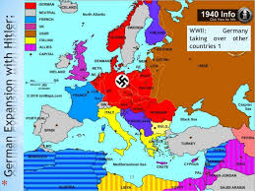 | Maths  On VE day street parties took place all over the country to celebrate. Design a picnic with all of your favourite foods to have at your very own VE Day party. Challenge: Give yourself a budget of £50 and use supermarket websites to calculate the cost of your picnic. | English  Create a diary entry for a child in The Blitz  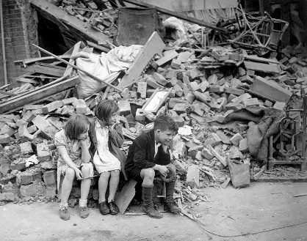
Science  Solve a problem using critical thinking skills. Parachute for an egg.  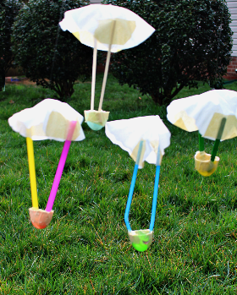 | Geography  Using a map, find some countries in Europe that were conquered during WW2. Note: some no longer exist :O  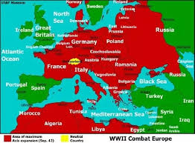 | RE  Create a fact file for the different religions found in India. | Music  Dance with your hands. Whilst listening to a piece of music draw what you feel. You can use a variety of colouring utensils while you do this. Change it up a bit and listen to different styles of music and see if what you colour is different.  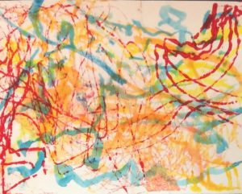
Remember to constantly challenge yourself. Can you do better?

