HISTORY  We are looking at natural disasters this term. Blizzards and Earthquakes are both natural disasters, what can you find out about these?  Create a fact file on both of these.  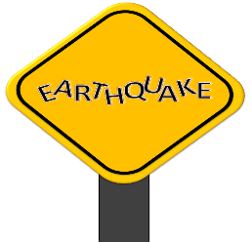  This Photo by Unknown Author is licensed under CC BY | ART  To celebrate St. George’s Day which is the 23rd of April try to create and design your own dragon or a coat of arms shield at home! Try to make it as colourful as you can. Be sure to take a picture of your unique work and send it on to us.  This Photo by Unknown Author is licensed under CC BY-NC-ND | RE  Write a diary entry about the Easter story from the point of view of one of the apostles.  How did you feel when you saw your best friend suffering?  Did you believe?  You could start your diary from Palm Sunday.  This Photo by Unknown Author is licensed under CC BY-NC-ND | LITERACY  Imagine a snowy scene, write about what you can see.  You must use at least three examples of apostrophes for plural possession. You could write about the trees, the footsteps, or the children. Can you think of some of your own examples?  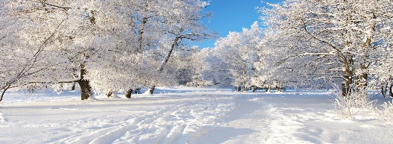  This Photo by Unknown Author is licensed under CC BY-NC-ND
MATHS  Create your own emoji math code breaking worksheet. You can use a different emoji for each digit from 0-9. Which means you need to think of 10 different emojis to use.  Use the 4 operations of maths to create some sums.  Have fun, we look forward to cracking these codes! | SCIENCE  Can you draw and label a diagram of the teeth and their functions?  Compare human teeth to animal teeth, what are the differences you find?  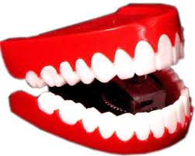  This Photo by Unknown Author is licensed under CC BY | _{GEOGRAPHY}  Design and create your own volcano.  _{You will need:}  Washing up liquid, Vinegar, Plastic cup, Bicarbonate of soda ,Red food colouring  _{Method:}  1. Fill your cup just over half full with water, add 3 teaspoons of bicarbonate of soda and give it a good stir until most of the bicarbonate of soda dissolves. 2. Add two drops of red food colouring and a good squirt of washing up liquid into the cup and once again give it a stir. 3. Make sure your volcano is in the kitchen or outside (or somewhere you don’t mind making a mess). 4. Quickly pour in just under a quarter of a cup of vinegar and enjoy your very own volcanic eruption! | Outdoor Activity  For this activity you will need a selection of leaves, some paint, and a paint brush.  You can paint the leaves using bright colours. Look closely at the shape of the leaf and the bumpy veins the leaf has.  Experiment with different marks and strokes with your brushes.  Finally create a collage with your creation! Use other materials to help you.  